Comparing ASDS to Existing Software
For Engineering Conceptual Design

Alicia Bargar¹, Daniel Kulas², Allyson Poston³
Trevor Richardson⁴, Michael Oren⁴, Ph.D., Bennett Stone⁴
Eliot Winer⁴, Ph.D., Stephen Gilbert⁴, Ph.D., Seda Yilmaz⁴, Ph.D.
Iowa State University, Virtual Reality Applications Center, Ames, IA, 50011

ABSTRACT
The Advanced Systems Design Suite (ASDS) is an application for aiding engineers in conceptual design work. It has been specifically tailored for use in this process by eliminating the need for specific details before analysis, which is unique compared to computer-aided design (CAD) programs or drafting commonly used at this stage in development. Additionally, ASDS can be used in immersive virtual reality systems to allow engineers to examine a virtual life-size model of the product, which allows them to test designs before doing any physical construction. The goals of ASDS are to make conceptual design a more efficient process for professional engineers, which would lead to faster and more cost-effective development of innovative products by engineering companies.
In this paper, we present the results of a study that examined whether ASDS is more beneficial in the conceptual design process than traditional CAD software in terms of efficiency, user satisfaction, and perceived ease of use by professional engineers and engineering majors with experience in design.

Keywords
Conceptual design, Computer-aided design (CAD) software

INTRODUCTION

Conceptual Design
Conceptual design is the first phase in the design process of a product. It is “perhaps the most crucial task in an engineering product development cycle” [1]. This is because the initial design of the product has a large impact on the manufacturing productivity and product quality. Up to 75% of the cost of a product is committed during the conceptual design phase [2]. The quality of the design has a significant effect on the final product as well; a poor conceptual design cannot be salvaged by a well-detailed design later in the process [2]. The amount of computer software created to aid engineers in the conceptual design phase remains relatively few, however, compared to the later, more detail-intensive phases. This is because during the conceptual design process, design requirements and details are still imprecise and open to change; this makes it difficult for engineers to make use of the detail-heavy computer-based systems or prototypes [1].

Computer Aided Design (CAD) Software
Computer-aided design (CAD) software is one of the leading methods for product design. “Many companies have turned to CAD systems to improve their product development effectiveness” [6]. Relations between CAD and increased product development performance and reduction in price and manufacturing costs have been found [3]. They have been used for tasks ranging from analysis and calculations to initial design and prototyping. CAD is also frequently used by businesses for the conceptual design process. However, “the effective application of CAD technology has proven to be a difficult task in many companies…Even when CAD technology is applied in ways that produce ostensible gains, these gains may not translate into overall improvements in product development effectiveness” [6]. In particular, it has been argued that CAD may not be the best choice for the conceptual design process due to the complexity of its interface and steep learning curve [8, 4]. People want to learn by trial and reasoning, which inclines them to jump around between sections; this is a learning process that is incompatible with the difficult process of learning CAD software [9]. Learning CAD software is a highly cognitive process due to its complexity [5]. Conceptual design is a highly creative process, and the complexity of CAD may hinder this process [10]. Especially during the process of redesigning an existing product, CAD presents numerous difficulties and inefficiency [11]. Figure 1 shows three toolbars in Autodesk Inventor 2011 (a commonly used CAD program) that are necessary to create and assemble parts. The number of toolbars needed and the number of tools located on each toolbar exemplify the complexity of a typical CAD program.
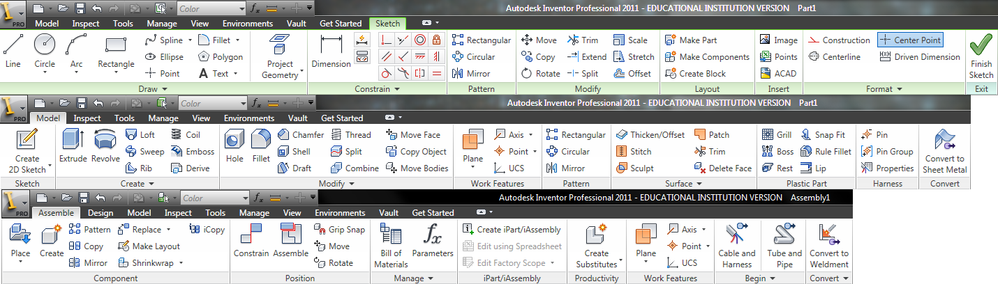
Figure 1: Three combined tool bars for Autodesk Inventor 2011. The top toolbar is for sketching a 2d part; the middle bar is for creating a 3d model; and the bottom bar is used for assembling and moving parts. All three are needed for assembly creation and manipulation.

Advanced Systems Design Suite (ASDS)
Alternative methods to CAD for conceptual design have been tested including a head-mounted display that allows the designer to examine their model in a virtual reality environment and a computer-aided sketching device that allows engineers to draw their designs on the screen [4]. The Advanced Systems Design Suite (ASDS) is a product designed specifically for creating conceptual engineering designs as 3D prototypes with a simplified interface and the ability to view them in a virtual reality environment. This form of modeling was chosen because the use of 3D prototypes makes for better visualization of the end product and can be used to analyze potential usability issues [7]. ASDS can be used to create 3D models from objects in standard or imported libraries or models from CAD modeling programs can be imported to be manipulated. This ability to coexist with CAD software allows for ASDS to be adopted for conceptual design purposes while retaining original CAD software for its proven usefulness in later design processes. One example that shows the comparative simplicity of ASDS to CAD is the ASDS toolbar; it contains a few tools that cover a variety of functions in a manner designed to be easy to understand. There is only one toolbar needed for any project in the program.

Figure 2: The tool bar for ASDS: this can be used for creating and manipulating individual parts or entire assemblies.

Research Question
This study addresses the question: How does ASDS compare to traditional CAD software in terms of efficiency, satisfaction, and ease of use in the conceptual design process, as perceived and reported by end users?

METHODS
For this experiment, we decided to compare the software component of ASDS to a traditional CAD program. This study was designed to compare ASDS to a CAD program because CAD has the most similar interface and modeling approach. Both CAD and ASDS are computer software products used for engineering design. They are used to create objects by manipulating and connecting primitive 3d shapes in a basic workspace environment. The program Autodesk Inventor 2011 was chosen specifically as the comparison product because it contains many of the features present in typical CAD programs, such as 3d shapes construction and manipulation and object mating. Six undergraduate and graduate students in engineering and science-related fields participated in the preliminary study. All had experience either with CAD programs- specifically, SolidWorks or Autodesk Inventor- or 3d modeling. Three used Autodesk Inventor 2011 during the study and three used ASDS.
In the future study, professional engineers will test the two programs. Professional engineers involved in product design are the ideal demographic for our future study because they should have the proper experience with engineering design and CAD programs and would be our target audience for ASDS. It is expected that this experience would translate into higher rates of efficiency, particularly on Inventor, and potentially a higher ranked ease of use.
The preliminary study had one independent variable: the software to be used, and three dependent variables: participants’ percentage of completion on tasks, the time spent on tasks, and participants’ responses on the end survey.
The usability metrics we measured were efficiency, satisfaction, and ease of use. Efficiency is defined as the amount of time taken to complete a task and the ability to successfully complete it. In this study we measured efficiency by timing the time it took the participant to complete each task and examining how many errors are present in the final product. Satisfaction reflects how positive the user’s experience with the product was, and was self-reported by the participant in the end survey. Ease of use measures how quickly the user was able to learn and use the program during the study. This was measured by the success rate and recorded times for completing tasks as well as by the self-report in the end survey.

Procedure
Participants used either Autodesk Inventor 2011 or ASDS. First, they watched a five-minute tutorial video on the program they were using, explaining where various functions of the programs are located. The purpose of this was to allow those without experience in their assigned program to get a general feel for the interface of the program. This was designed to cut down on the time they spent trying to navigate their way around the program during the actual study. After the tutorial video, they were required to complete two tasks. The tasks were the same for both ASDS and Autodesk Inventor 2011. Their screens were recorded during the tasks for later analysis.
The first task required the participant to finish assembling a provided model in ten minutes (Figure 3). They were given a diagram of the desired assembly and the individual parts in the assembly (Figure 4). To complete the assembly, the participant had to translate and rotate the parts before combining them according to the diagram. Figure 5 shows a participant during the process of completing the assembly. After the ten minutes passed, the researcher saved the participant’s files for later analysis.
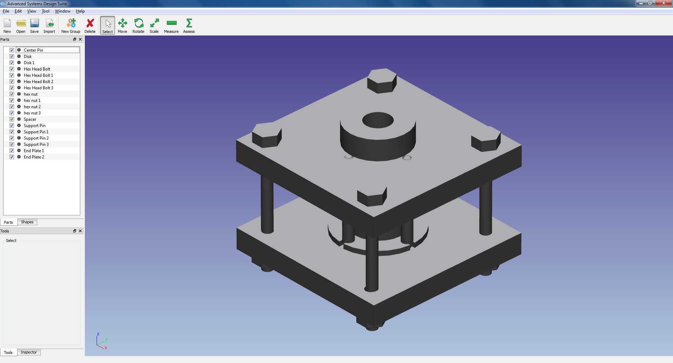
Figure 3: The final assembly goal for Task 1 (shown in ASDS)

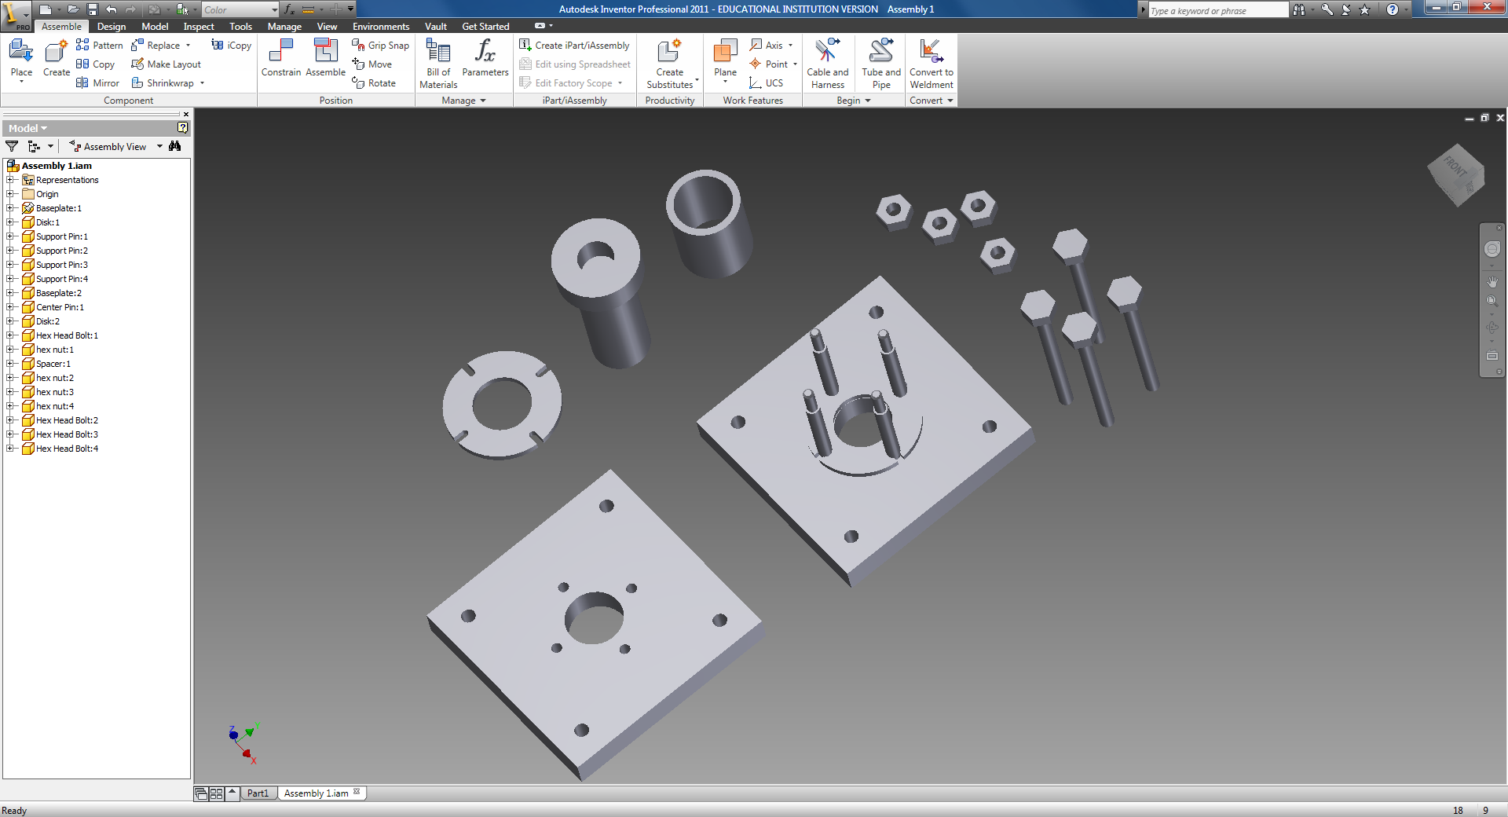
Figure 4: The parts given for the assembly in Task 1 (shown in Inventor)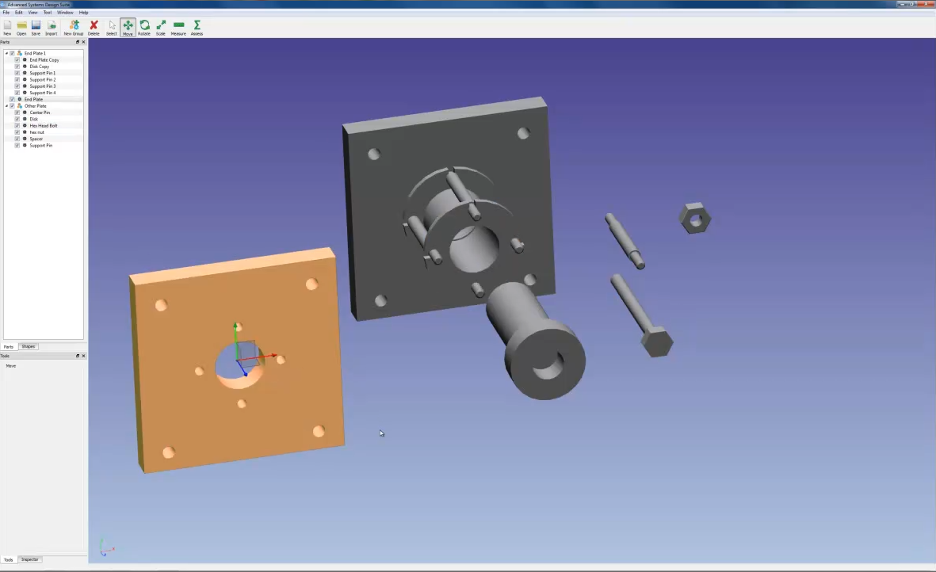
Figure 5: Participant assembles parts in ASDS during Task 1

For the second task, the participant had to make a modification to the assembly. All participants were supplied the fully assembled object so everyone began at the same level. Specifically, the participant had to change the square end plates (shown in Figure 6) to circular plates (shown in Figure 9). They were given ten minutes to complete this task. Participants were allowed to solve this task in whatever manner they chose; Figure 8 and Figure 9 show two participants trying different methods of changing the baseplates in the programs Autodesk Inventor and ASDS respectively.
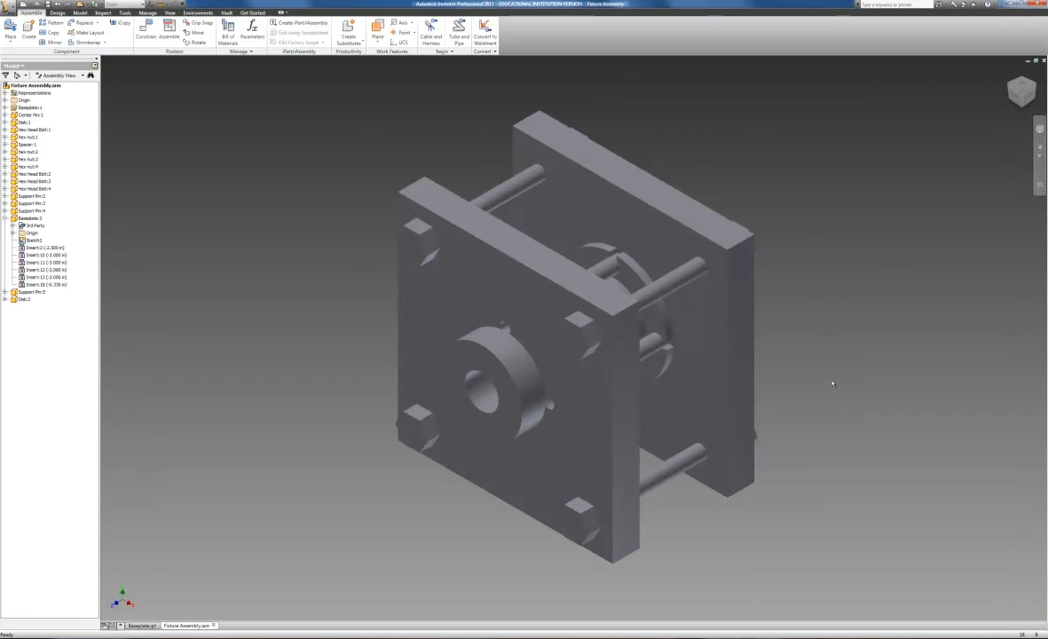
Figure 6: The given assembly with square baseplates at the beginning of Task 2 in Autodesk Inventor 2011

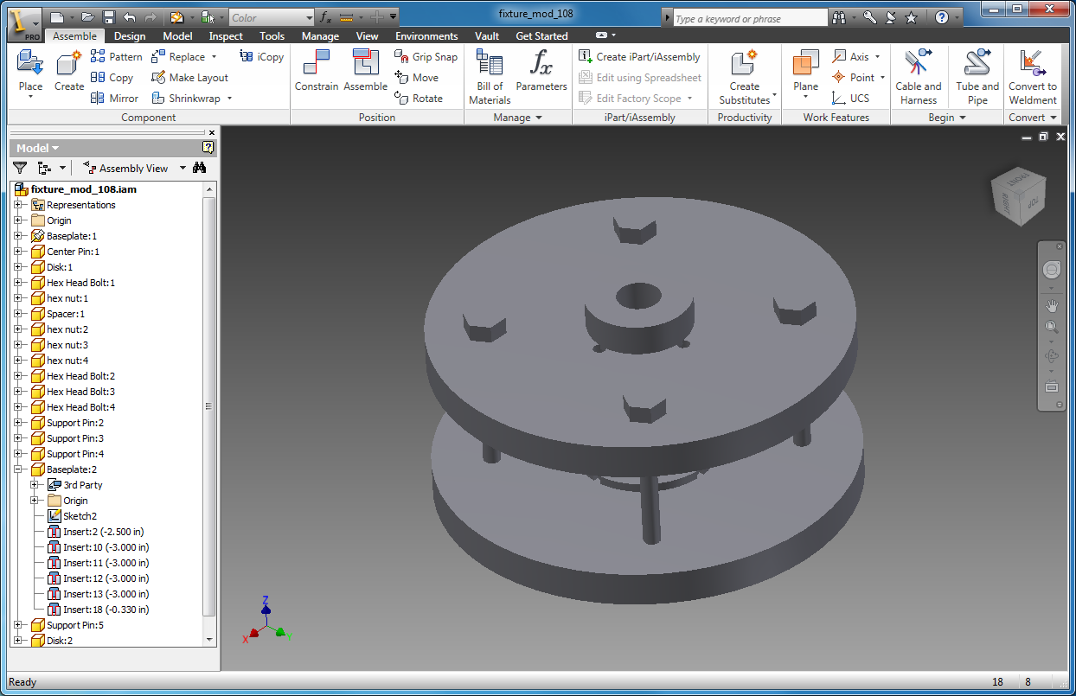
Figure 7: The goal assembly with circular baseplates for Task 2 (shown in Autodesk Inventor 2011)

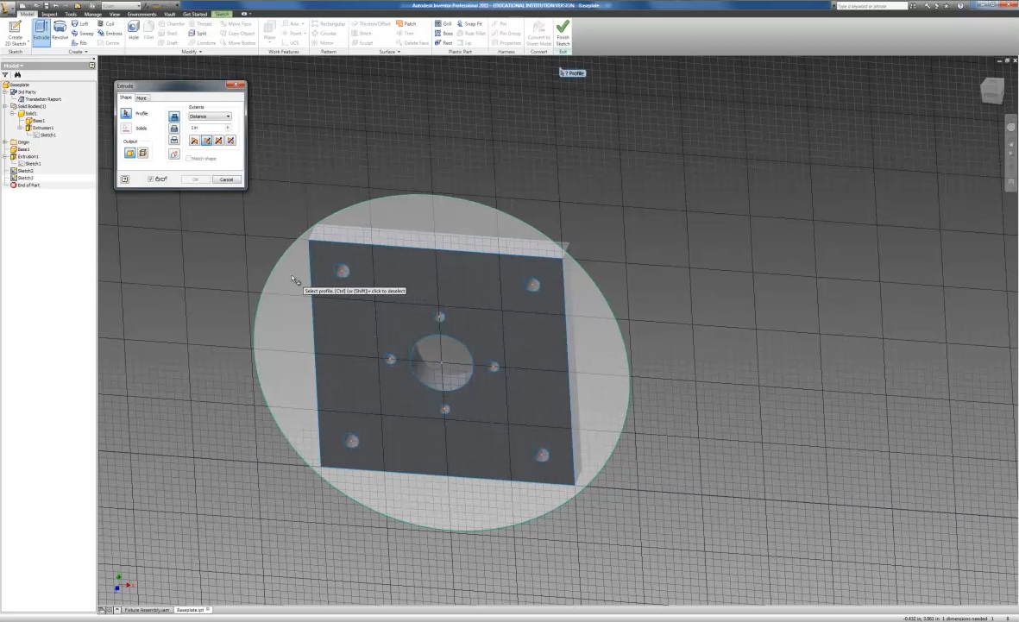
Figure 8: Participant modifies the baseplate design for Task 2 in Autodesk Inventor 2011

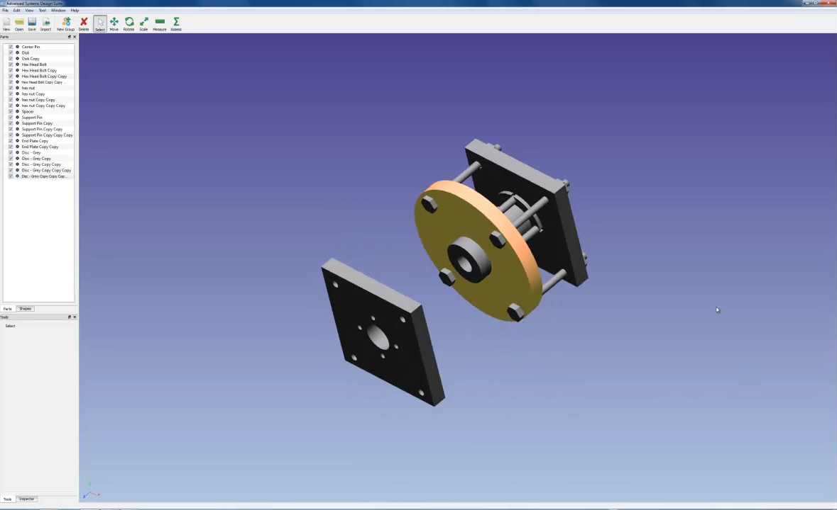
Figure 9: Participant modifies the baseplate design for Task 2 in ASDS.

After the ten minutes expired, the researcher saved the participant’s files for later analysis. The participants were then given an 18-question survey with Likert and free-response questions covering self-perception of efficiency, ease of use, and satisfaction with the used software. When each participant finished the survey, his/her part in the study was complete.

RESULTS
Despite the small sample size, a student T-test was performed on task performance and survey results with α=0.05. Only two (both in the ASDS group) of six participants completed Task 1 and this was marginally significant between groups (p=0.068). Percentage of completion as calculated for Task 2 is how much of the part creation and replacement in the assembly the participant accomplished. The tasks taken into account were the deletion of each base plate, the creation of each circular plate, and the positioning of each circular plate into the correct location in the assembly. The results for Task 2 were marginally significant (p-0.058) with all ASDS users completing 100% of the task and only one Inventor using completing the task.
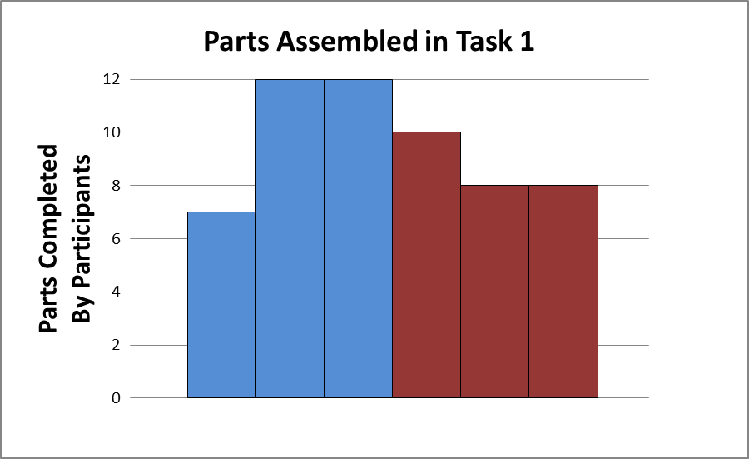
ASDS
Inventor
Graph 1: The number of parts successfully assembled by each participant (represented by individual bars) during Task 1 in the ASDS and Inventor programs.
Graph 1 shows how many parts each participant was able to complete during Task 1 in his/her assigned program (ASDS or Autodesk Inventor). The mean number of parts successfully assembled in ASDS and Inventor were 10.33 and 8.67 parts respectively. The standard deviation for ASDS was 2.89; for Inventor, the standard deviation was 1.15.
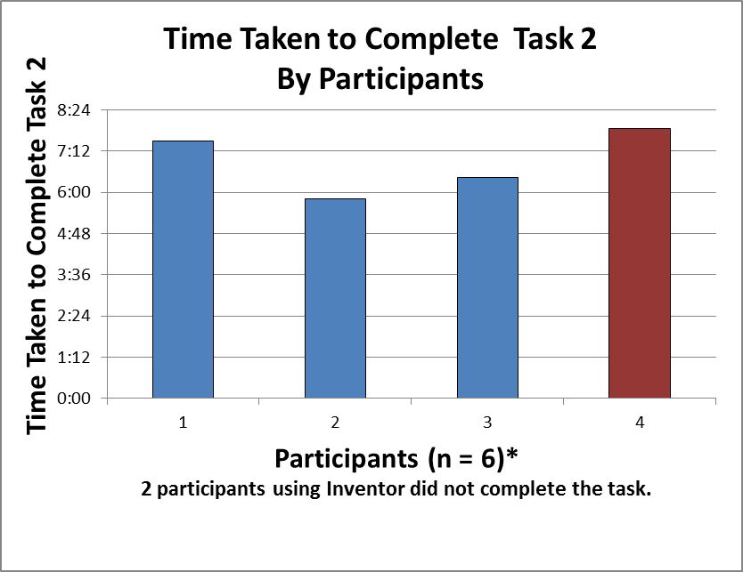
ASDS
Inventor
Graph 2: In Task 2, each participant was required to replace the two square baseplates with two circular baseplates. Two out of six participants did not complete this task; they both used Inventor. This is the amount of time it took the four successful participants to complete Task 2 by program.

Graph 2 shows how much time it took the participants who completed Task 2 to finish the task. The results for Task 2 completion time were significant with p=0.018, which suggests ASDS may reduce the time engineers take to do simple conceptual part design modifications
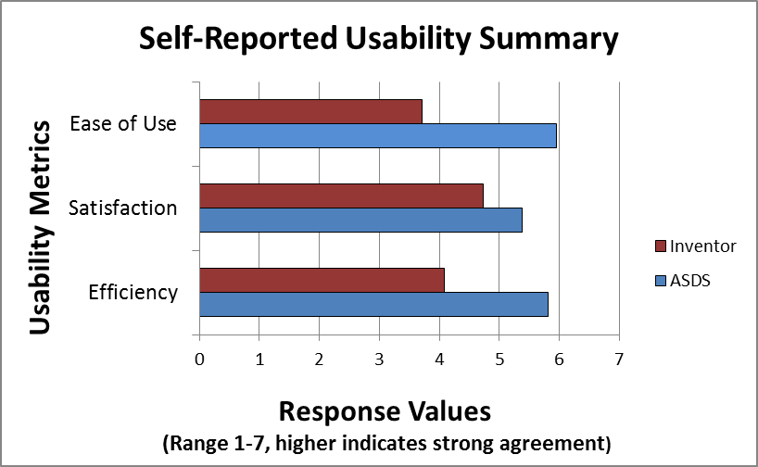
Graph 3: Users’ responses to the end survey averaged by program and then averaged by corresponding usability metric.

 | Mean(SD)
 | ASDS | Inventor
Efficiency | 5.82 (1.08) | 4.08 (1.73)
Satisfaction | 5.38 (1.12) | 4.73 (1.58)
Ease of Use | 5.95 (0.85) | 3.71 (1.38)
Table 1: Mean numeric values for usability metrics for each program. Standard deviations included in parenthesis. The highest ranking is 7 for ‘strongly agree’. The lowest ranking is 1 for ‘strongly disagree’.

Each question on the survey related to a specific usability metric. The user could rank their response to each question as a number from 1 to 7, 1 representing ‘strongly disagree’ and 7 representing ‘strongly agree.’ The users in each program’s responses to each question were averaged according to which usability metric they related. This is the resulting summarization of how the users’ survey responses related to their perceived ease of use, satisfaction, and efficiency. Table 1 shows the numeric values for each usability metric by program as represented in Graph 3. ASDS ranked higher than Inventor for all recorded usability metrics. A single-tailed t-test analysis was performed on each metric in Table 1. The results for both Efficiency (p=0.049) and Ease of Use (p=0.006) were found to be significantly different between groups.

DISCUSSION
While the small sample size and the demographics of the population are a limiting factor of this study, the results do indicate promise for the use of ASDS for conceptual assembly and part modification. Since the results were significant with such a small sample size, this may suggest a particularly large gap on the efficiency and ease of use of ASDS over Inventor.

Task 1
In Task 1, it was found that more people were able to complete the assembly in ASDS than Inventor within the given 10 minutes (Graph 1). This could indicate that ASDS has a more efficient assembly process than Autodesk Inventor. However, the number of parts each participant completed was steadier among the Inventor participants (standard deviation: 1.15) than among the ASDS participants (standard deviation: 2.89). This could indicate that ASDS is more efficient for some participants but less efficient for others, while those using Autodesk Inventor have a more consistent performance. In order to study this phenomenon further, we would need to have more participants perform Task 1 in each program.
Task 2
Out of the six participants in the study, only four successfully completed Task 2. Out of the four people who completed Task 2, three used ASDS. Additionally, all three participants using ASDS completed before the Inventor participant; one participant using ASDS completed more than two minutes before the Inventor participant. This indicates that ASDS is the more efficient method to use for the process of modifying an assembly. Additionally, the two participants who did not complete the assembly in Inventor were unsure of how to begin the assembly and spent most of the time clicking around the screen. This indicates that Inventor is not as easy to understand and use for this process as ASDS.
One concern prior to the study regarding participants’ success in Task 2 in the ASDS program was whether their performance would be affected by confusion over how to create holes in ASDS (there is currently no method for creating holes in ASDS). The square baseplates contain holes, and it was thought that participants might struggle to create holes in the circular disks before adding them to the assembly (no holes are required for assembly implementation). However, this did not appear to affect Task 2 performance for the ASDS program as all three participants successfully replaced both baseplates.
In Autodesk Inventor, some participants did not understand how to replace the baseplates. They continuously tried modifying the baseplates while in assembly mode, although there were more efficient ways to go about performing the modification. this resulted in a lack of success for replacing either baseplate. This could be affected by the participants’ prior experience in SolidWorks, a CAD program that has more overlap between part mode and assembly mode than Autodesk Inventor and would be a program in which this approach to the task would be met with success. Prior experience with SolidWorks would not affect ASDS performance because part mode and assembly mode are fully integrated within the ASDS program. To determine whether prior experience with SolidWorks affected participants’ mental model regarding the problem and their ability to complete Task 2 in Autodesk Inventor, we would need to test participants with SolidWorks experience and participants without SolidWorks experience performing Task 2 in Inventor and determine if the difference in results was significant.
Another possible reason for participants’ inability to complete Task 2 in Inventor could be their confusion regarding what they were permitted to do in the program. One participant noted in his/her comments in the end survey that he/she did not know what actions they were allowed in the program, including whether creating a new part file was acceptable. To prevent this problem from occurring again, the researchers will state before the tasks that any method of solving the tasks is allowed, including any and all actions the participant deems to use.
Summary
Overall, these results are promising indicators of what a future, larger study might yield. However, six participants are not enough to be truly indicative of overlying trends, so it is possible that the trends currently seen could prove to be unrepresentative of a larger population. We will need to perform a larger study to find out if this is the case.
The population that will be tested in the actual study will be different from our current population in that they will be professional engineers with CAD experience, instead of students with either CAD or modeling experience. The engineering population may prove to be more efficient, particularly in Autodesk Inventor, if they have more extensive experience with CAD programs in general.

CONCLUSION

Implications
Without more participants’ results, generalizations of overall trends cannot be made. However, these preliminary results are promising by indicating, with data from Task 1, Task 2, and the survey, that participants are more efficient when creating assemblies in ASDS than in Inventor; that they are more likely to infer how to modify and replace parts in ASDS within a ten minute time limit; and that they rank their experience higher in ASDS among the usability objectives of Ease of Use, Satisfaction, and Efficiency.

Future Work
In the near future, we will perform a study with more participants from the target audience of professional engineers to determine how they perform in ASDS as compared to Autodesk Inventor. Later on, we hope to use a similar study template to compare ASDS to other conceptual design methods, ranging from other CAD software to data analysis methods to drafting by hand. Software development on ASDS will continue as comments from participants and study results add to our understanding of the usability of ASDS by the target audience.

REFERENCES
- Wang, L, Shen, W, Xie, H, Neelamkavil, J, and Pardasani, A. Collaborative conceptual design—state of the art and future trends. Computer-Aided Design 34, 13 (November 2002), 981-996.
- Hsu, W., and Woon, I. M. Y. Current research in the conceptual design of mechanical products. Computer-Aided Design 30, 5 (April 1998), 377-389.
- Tan, C. L. and Vonderembse, M. A. Mediating effects of computer-aided design usage: From concurrent engineering to product development performance. Journal of Operations Management 24, 5 (September 2006), 494-510.
- Kaufmann, H. and Dünser, A. Summary of Usability Evaluations of an Educational Augmented Reality Application. R. Schumaker: Virtual Reality, Lecture Notes in Computer Science 4563 (2007), Springer- Verlag Berlin Heidelberg, 660-669.
- Hamade, R. F., Artail, H. A., and Jaber, M. Y. Evaluating the learning process of mechanical CAD students. Computers & Education 49, 3 (November 2007), 640-661.
- Robertson, D. and Allen, T. J. CAD system use and engineering performance. IEEE Transactions on Engineering Management 40, 3 (August 1993), 274-282.
- Kuutti, K., Battarbee, K., Säde, S., Mattelmäki, T, Keinonen, T., Teirikko, T., and Tornberg, A. Virtual Prototypes in Usability Testing. Proceedings of the 34th Annual Hawaii International Conference on System Sciences, 5 (2001), 5029.

- Plimmer, B. and Apperley, M. Computer-aided sketching to capture preliminary design. Aust. Comput. Sci. Commun. 24, 4 (January 2002), 9-12.
- Carroll, J. M. Human-computer interaction: psychology as a science of design. Annual Review of Psychology 48, (1997), 61-84.
- Dixon, J. R. On research methodology towards a scientific theory of engineering design. Artif. Intell. Engng Des. Anal. Mfg 1, 3 (1988), 145–157.

- Gu, P., Xue, D., and Nee, A. Y. C. Adaptable design: concepts, methods, and applications. Proc. IMechE, Part B: J. Engineering Manufacture 223, (2009), 367–387.

