Mitigating Cybersickness: A virtual hand-eye coordination task
Kayla Dawson, Kelli Jackson, Liat Litwin
Michael Curtis
Michael Dorneich, PhD; Jonathan Kelly, Stephen Gilbert, PhD; Richard Stone, PhD; Eliot Winer, PhD
Iowa State University Virtual Reality Applications Center, Ames, IA 50010

Abstract
Experimental research was carried out to investigate the benefits and limitations of a virtual cybersickness mitigation technique. Virtual reality has grown rapidly over the past decade, and many fields are utilizing this technology in a variety of ways. Yet cybersickness, or visually induced motion sickness, continues to be a major factor affecting the usability of this technology. Physical hand-eye-coordination tasks have been found to be effective in mitigating symptoms of cybersickness, allowing for the recalibration of senses after a period of decreased depth perception. However, the need for external equipment outside of the virtual environment (VE) limits the usefulness of the technique. The development of an equivalent virtual task within the VE would allow for more a convenient and integrated mitigation technique. In a between subjects design, a virtual mitigation task was compared to the effect of allowing symptoms to naturally decay. Results demonstrated that a virtual task is effective in reducing nausea symptoms but does not reduce the oculomotor symptoms of users. Disorientation decreased a nearly significant amount after completing the virtual hand-eye coordination task. This research will provide valuable information towards developing mitigation techniques that can be used within the VE.

Introduction
Virtual Reality is a promising technology that has the potential to revolutionize many fields from education to entertainment. However, when exposed to virtual reality environments (VE) over 80% of users experience a cluster of symptoms called cybersickness (Stanney & Kennedy, 1998). Also known as simulator sickness, this condition refers to a specific type of motion sickness that is primarily visually induced (Cobb, Nichols, Ramsey, & Wilson, 1999). The symptoms can be broken down into nausea, oculomotor (headache and eyestrain), and disorientation (Kennedy, Lane, Berbaum, & Lilienthal, 1993). Cybersickness is an issue for users and designers of virtual reality environments because it impacts the usability of these systems. Users who experience frequent or severe symptoms are less likely to use virtual reality technology, which can be extremely detrimental to the supplier. The severity of the symptoms can impact the performance of users of virtual reality and can force users to exit the environment, potentially impacting studies that incorporate these types of technology.
There are several theories as to why and how cybersickness symptoms occur, but the most common is of which is, the sensory-conflict theory. The sensory-conflict theory explains that immersed users of virtual reality will experience a convincing feeling of self-motion (vection) from the display, even though their bodies remain stationary (Cobb, Nichols, Ramsey, & Wilson, 1999). The conflicting information from the visual and vestibular systems confuses the brain and thus leads to cybersickness. Currently, there are no known techniques to eliminate the symptoms of cybersickness without medication. Research in the field has focused primarily on identifying factors that cause cybersickness (LaViola, 2000). However, because symptoms of cybersickness can last for hours after re-immersion into the physical world (Thomley, Kennedy, & Bittner, 1986), it is important to investigate methods to mitigate symptoms after a virtual task has been completed. Hand-eye coordination tasks are thought to help reconcile conflicting senses that have been disconnected (Champney et al., 2007) because it forces the user to focus and can lead to the realignment of the oculomotor system. Therefore, there exists an opportunity to develop a mitigation technique that can facilitate the realigning of senses in order to reduce symptoms of cybersickness.

Background
Cybersickness has been a debilitating aspect of virtual environments (VE) for as long as they have existed. Research has focused on identifying factors that contribute to increased symptoms of cybersickness as well as mitigation techniques that can help reduce the symptoms.

Factors. Before possible mitigation techniques can be considered, the facts that contribute to cybersickness must be considered as well. The sensory conflict theory is the most widely accepted theory relating to cybersickness (LaViola, 2000). A number of factors have been found to increase the disconnect between senses, further illuminating this theory. So and Lo (1998) conducted a study exploring the effects of scene movement in users wearing a head mounted display(HMD). They concluded that more scene movement led to increased symptoms, confirming that cybersickness is visually induced. Bonato, Bubka, and Palmisano (2009) continued the investigation on scene rotations by comparing single axis rotations with dual axis rotations. They found that a VR stimulus rotating about two axes can lead to increased cybersickness symptoms due to sensory conflict. Perceived self-motion is more complex with two axes, leading to a greater disconnect (Bonato et al., 2009). A variety of other cybersickness inducing factors are also attributed to the sensory conflict theory. Increased head movement causes the vestibular system to report more movement that is not supported by the visual information perceived on the screen (Howarth & Finch, 1999). Furthermore, when subjects are not in control of the VE (i.e onlookers) they do not have the same internal expectations of motion, and thus have been found to experience greater cybersickness symptoms than those in control (Dong, Yoshida, & Stoffregen, 2011).
In looking at how the display may contribute to sensory conflict, and thus impact cybersickness, researchers have investigated the effects of lag and frame rate. Lag, or the delay between when the user moves and when the scene updates, can lead to increased oculomotor symptoms (Dizo & Lackner, 1997). In a comparison study, Dizio and Lackner (1997) concluded that sickness continuously increased in participants when lag increased from 67ms to 367ms. When the scene does not update continuously, as the user expects it to, a conflict between senses occurs, thus increasing cybersickness. Furthermore, the frequency at which an imaging device produces unique consecutive images, referred to as frame rate, was studied by Lo and So (2001). Their results indicated that delayed frame rate may be a leading factor to triggering cybersickness. Consistent with the sensory-conflict theory, they hypothesized that users associate a delay in frame rate with the feeling of vection because it causes them to feel as though they are moving even while remaining still. In reality, the human eye and brain interface can process ten to twelve images per second (Read & Meyer, 2000), meaning that the frame rate within a VRE could become a problem for the user if they were not to remain stationary during their exposure.
The type of system used in virtual reality has a significant effect on the intensity of cybersickness symptoms. In a study conducted by Subramanian and Levin (2011), subjects who used a HMD in a pointing task were found to make a larger number of errors than the subjects who used a large screen projection system. The authors suggest that the reduced field of view (FOV) and the weight of the HMD both factored into the reduced precision subjects exhibited in the study. In another comparison study, participants experienced more symptoms in the HMD condition as compared to a desktop display and a reality theater (Sharples, Cobb, Moody, & Wilson, 2008). Thus, research indicates that HMD use is one of the primary situations in which cybersickness symptoms are most commonly induced. The current study utilizes this fact to investigate possible mitigation techniques in a platform that has been found to result in a higher rate of symptoms. A multiple of factors have been found to correlate with the increased number of cybersickness symptoms found in HMD use.
Mitigation. While it is critical to investigate factors that contribute to cybersickness, there is a movement to develop mitigation techniques that users can perform in order to recover from symptoms quickly. Champney et al. (2007) predicted that physical tasks requiring the coordination of multiple sensory systems could recalibrate the senses. They measured hand-eye coordination to determine recovery amongst users who were exposed to a virtual reality environment for 1 hour. A hand-eye coordination task allows users to realign their senses after a period of decreased depth perception (Champney et al., 2007). A common hand-eye coordination task is the use of a peg board utilizing a peg-in-hole task. This type of task involves the insertion of wooden dowels into appropriate holes. Past studies have found that participants exhibit a temporary decrease in depth perception when using a head mounted display (HMD) system in a 3D VE (Stone, Watts, & Rosenquist, 2012). A peg-in-hole task can be used as a practical method by which to reconcile the senses and allow the participant to regain their perception of depth. Champney et al. (2007) concluded that participants who completed the peg-in-hole task after immersion in a VE recovered significantly faster than those who allowed for symptoms to decay naturally.
The work of Champney et al. demonstrates that peg-in-hole tasks performed by a user after exposure to a virtual reality environment can help the user regain hand-eye coordination faster than natural decay. However, previous work evaluating depth perception and hand-eye coordination of a user recovering from cybersickness symptoms have relied on physical equipment in addition to the visual display. This equipment requires users to exit the VE completely to mitigate their symptoms and is so specialized that many users would not have access to it. If a similar task can be completed within the VE, it would not require additional equipment, and thus can be utilized more frequently and with more ease in order to combat cybersickness symptoms. Our research will therefore investigate the effectiveness of a virtual peg-in-hole task as compared to the natural decay of symptoms in order to determine its potential as a mitigation technique.

Methods
Participants
There were 21 participants recruited from students and employees of Iowa State University. The participants (12 male and 9 female), ranging in age from 19 to 31 years (mean = 21.7, SD = 3.08), were compensated for their time with a payment of $20.

Apparatus
An nVisor SX111 HMD was used to displays graphics and track the users’ movements. The nVisor weighed 1.3 kilograms and has 111° field of view with 1280x1024 resolution. It was used in stereo mode throughout the duration of the experiment. Users were given the opportunity to adjust the HMD according to their comfort before beginning the task.

Independent variables
The independent variable was “mitigation” that had two levels: natural decay and virtual peg-in-hole. Subjects either completed a virtual peg-in-hole task or waited for symptoms to naturally decay.

Experimental Design
The experiment was a 1-factor (mitigation) between subjects design. Participants were randomly assigned one of two mitigation tasks: virtual peg-in-hole or natural decay. Ten subjects were in the virtual peg-in-hole condition, and eleven subjects were in the natural decay condition.

Tasks
Participants were immersed in a maze-like VE designed specifically to induce symptoms of cybersickness. They navigated through an obstacle course in a virtual maze. The course employed several factors that previously had been found to cause increased cybersickness symptoms. The maze was designed with 44 ninety degree turns, a section where the user lost control, and multiple obstacles they had to get through in order to complete the maze. Such obstacles included jumping over objects, falling into and climbing out of pits, going through a revolving checkered barrel, climbing up walls and ramps, and sliding down slides. Coins throughout the maze directed the user on the right path and they were given the option to collect the coins in the maze, but were not required to. Subjects were asked to navigate through the maze for a total of 15 minutes but were allowed to exit the environment early if they experienced severe cybersickness symptoms.
Some participants, after completing the maze task, were randomly selected to complete a virtual peg-in-hole task (figure 1) designed to mimic a similar real-world task from previous research. This task was completed in the same HMD as the original maze task. The user was asked to place the pegs into the straw-like holes from back to front, just as in the experiment with a physical peg-in-hole task (Stone et al., 2012). The participant was given directions on how to navigate the peg through the scene using the Logitech controller. Arrow keys were used to navigate forward, backward, left, and right, and buttons 4 and 2 translated the peg up and down respectively on the y-axis.
Other participants, after completing the maze task, were asked to remain seated and relax for a period of 15 minutes, which was approximately the amount of time they spent in the maze, and acted as a control
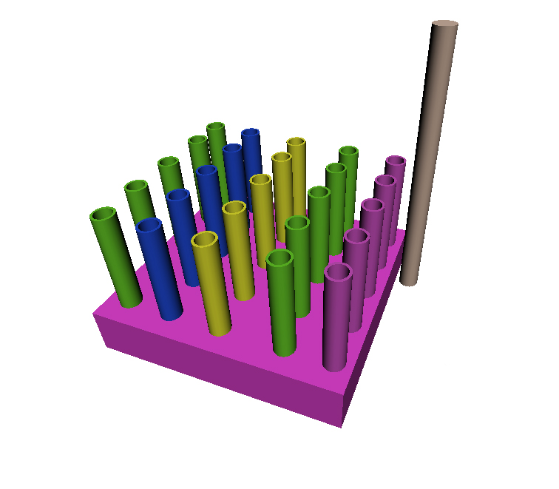
Figure 1. Virtual peg-in-hole task

Dependent Variables
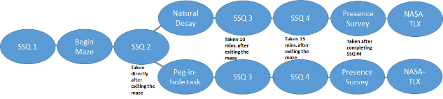
In order to test the effectiveness of the manipulated variables, the symptoms of cybersickness were measured. Furthermore, presence, or the illusion of actually being immersed in the VE, has been found to be highly correlated with cybersickness symptoms. Therefore, presence served as an additional measure in order to identify the extent of users’ symptoms. Finally, in order to evaluate the effort required in the virtual peg-in-hole task, workload was measured.
Figure 2. Flowchart of experiment protocol.
Simulator sickness. The Simulator Sickness Questionnaire (SSQ) (Kennedy et al., 1993) was used to assess symptoms of cybersickness throughout the study and breaks symptoms into three main categories: oculomotor, disorientation, and nausea (Kennedy et al., 1993). Subjects completed the SSQ before beginning the maze, directly after completing it, and then at 10 minutes and 15 minutes while waiting for symptoms to subside.
Presence. The Presence Questionnaire (PQ)(Witmer & Singer, 1994) was used as an indicator of how immersed the participants felt in the maze environment.
Workload. Participants were asked to complete the NASA-TLX for the time spent completing the peg-in-hole task compared to during natural decay. This is an important measure as it indicates the subjective workload experienced by users, including their level of mental demand, effort, and frustration while completing the task.

Procedure
After completing a short demographics survey, participants were administered an initial simulator sickness questionnaire (SSQ #1) to determine a baseline. As shown in figure 1, participants then completed the virtual maze which induced cybersickness, after which they completed another SSQ (SSQ #2). Participants then either completed the virtual peg-in-hole task or waited 15 minutes as symptoms decayed before completing a third SSQ (SSQ #3). Subjects completed a final SSQ (SSQ #4) at 15 minutes after the time they exited the virtual maze. In a series of post-experiment surveys, participants completed a presence survey to determine the level of immersion that they felt while traveling through the maze and a NASA-TLX as a measurement of their workload during the mitigation phase.

Data Analysis
Two tailed t tests were used to measure the statistical significance among sets of data. Unpaired t tests were used to compare symptom scores from the peg-in-hole task group to the natural decay group. Paired t tests were used to compare symptom scores within a group over time. A p value less than 0.05 was considered statistically significant.
In analyzing data, SSQ scores were subdivided into three categories: nausea, oculomotor, and disorientation. These categories provided a more detailed understanding of the changes in cybersickness symptoms.

Results
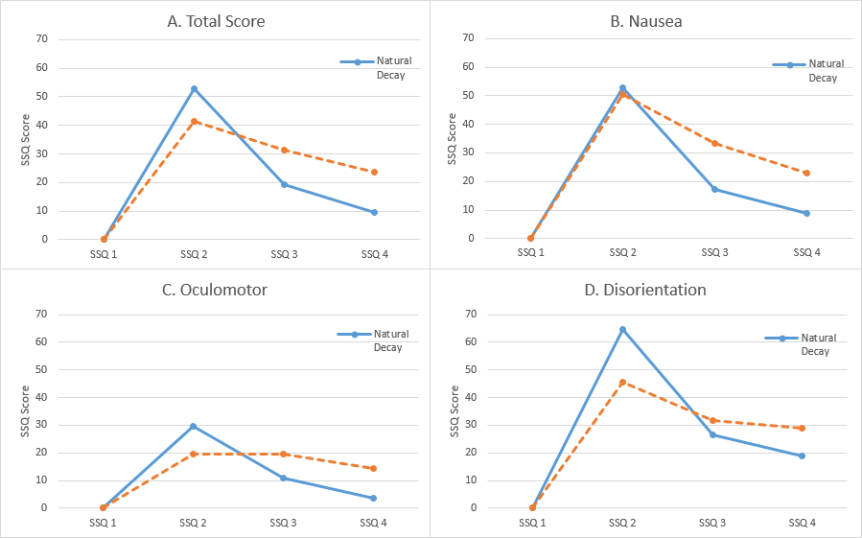
The average time spent in the maze was 10 minutes and 2 seconds (SD= 3 minutes and 26 seconds). Cybersickness symptoms were significantly increased (p<0.0001) by the obstacle course maze. SSQ #2 scores, and all subscores of nausea, oculomotor, and disorientation, increased significantly from the baseline SSQ #1 scores (figure 2). The average presence score for all participants was 97.33. The average time spent completing the virtual peg-in-hole task was 7 minutes and 4 seconds.
Figure 3. Average SSQ total scores and subscores for both mitigation techniques
The NASA-TLX score for one participant was removed because it was more than three standard deviations away from the mean of the data. It is possible that the participant did not understand the questions because he rated the physical demand of the natural decay task to be a 15 (with 20 being the most physically demanding) while everyone else in the natural decay group rated the physical demand a 1 (the lowest possible score). The average total NASA-TLX score for the remaining 10 in the natural decay was 10.1. For the virtual peg-in-hole group the average total score was 42.5. A significant difference (p < .0001) exists between the NASA-TLX scores of the peg-in-hole task and natural decay.
There was not a significant difference between the SSQ scores or subscores between the peg-in-hole and natural decay groups when comparing SSQ scores at the same time interval across conditions. SSQ #3 nausea symptoms were significantly reduced (p<0.048) as compared to SSQ #2 (figure 2B) in the peg-in-hole condition. Furthermore, SSQ #3 disorientation symptoms decreased slightly (p< .0629) as compared to SSQ #2 for those who completed the virtual peg-in-hole task.
The change in SSQ scores (from SSQ #2 to SSQ #3) for natural decay was found to be significantly better than the peg-in-hole condition only for the total score and oculomotor score (figures 2A and 2C). There was no significant difference between the slopes of the nausea and disorientation SSQ scores for that 10 minute time period across the two conditions (figures 2B and 2D).
For the peg-in-hole condition, oculomotor scores displayed no change across SSQ #2 and SSQ #3. There was a significant decrease in oculomotor SSQ scores for the natural decay condition (figure 2C).

Discussion and Conclusion

Cybersickness symptoms increased dramatically after participants were exposed to the maze environment. Every participant indicated at least a slight increase in at least one symptom on the SSQ. Therefore, the virtual maze task was a successful method to induce cybersickness. Utilizing past research and identifying factors known to cause cybersickness provides a useful method by which to design an environment intended to makes subjects exhibit increased symptoms.
Although cybersickness symptoms are expected to increase with continued exposure to a VE, there was no significant increase in symptoms from completing the virtual peg-in-hole task. In fact, nausea symptoms significantly decreased, demonstrating the potential of a virtual task as a mitigation technique. There was no significant change in oculomotor symptoms of users who completed the virtual peg-in-hole task. While symptoms did not worsen, there was no improvement and the average oculomotor score remained steady across SSQ’s #2 and #3. This points to one of the disadvantages of a virtual mitigation task. It is possible that the stress on the oculomotor system cannot be alleviated without exiting the VE, simply due to the nature of staring at a screen. However, the significant improvement in nausea symptoms demonstrates the potential of a virtual mitigation task for users who are unable to leave the environment. All participants completed an SSQ ten minutes after exiting the maze even though the peg-in-hole task group spent an average of 7 minutes and 4 seconds performing the mitigation technique. Therefore, some natural decay impacted the scores of the peg-in-hole group. There also appears to be a noticeable difference among the two conditions for the SSQ #2 scores; however, that difference is not statistically significant. This slight difference was probably due to the small sample size and variability among subjects to get sick. Conditions did not differ in the time period between SSQ #1 and SSQ #2.
NASA-TLX scores were recorded so that the virtual peg-in-hole task could be compared to other mitigation tasks in future research. The workload of completing the virtual peg-in-hole task is significantly higher than that of natural decay. However, the advantage of being able to remain inside the VE may justify the additional workload for many situations.
This development of a virtual mitigation technique is an important aspect in addressing the issues of cybersickness. While removing oneself from the VE may be the most effective method of recovering from the symptoms of cybersickness, this is not always a viable or desired option. Therefore, a virtual mitigation method allows for the continued immersion in a VE and a way to recover from symptoms. Symptoms did not worsen when subjects were immersed in the virtual peg-in-hole task, even though subjects were still immersed in a VE, demonstrating the ability for this to be an effective manner of mitigation. Future work must compare the benefits of a virtual hand-eye coordination task to a physical one, previously found successful. Furthermore, due to the individual variability among users and their susceptibility to get sick, the results of this study could be enhanced if it were to be repeated as a within-subjects design. Continued research may also look into the effectiveness of other hand-eye coordination tasks that can be developed and used during immersion in a VE, allowing users to experience virtual reality environments to their greatest potential.

Acknowledgements
The authors thank Ken Kopecky, Paul Easker, Trevor Richardson, Rafael Radkowski, and Joseph Holub for technical assistance. The authors would also like to thank all participants for their willingness to participate in the user study. We also acknowledge the National Science Foundation for financially supporting this project through NSF Grant CNS-1156841

References

Ames, S. L., Wolffsohn, J. S., & Mcbrien, N. A. (2005). The development of a symptom questionnaire for assessing virtual reality viewing using a head-mounted display. Optometry & Vision Science, 82(3), 168-176.
Bonato, F., Bubka A., Palmisano, S. A. (2009). Combined Pitch and Roll and Cybersickness in a Virtual Environment. Aviation, Space and Environmental Medicine, 80 (11) 941-945.
Bruck, S., & Watters, P. A. (2011). The factor structure of cybersickness. Displays, 32(4), 153-158.
Champney, R. K., Stanney, K. M., Hash, P. A., Malone, L. C., Kennedy, R. S., & Compton, D. E. (2007). Recovery from virtual environment exposure: Expected time course of symptoms and potential readaptation strategies. Human Factors: The Journal of the Human Factors and Ergonomics Society, 49(3), 491-506.
Chang, E., Hwang, I., Jeon, H., Chun, Y. (2013). Effects of rest frames on cybersickness and oscillatory brain activity. Brain-Computer Interface International Workshop. 62-64
Cobb, S. V., Nichols, S., Ramsey, A., & Wilson, J. R. (1999). Virtual reality-induced symptoms and effects (VRISE). Presence: Teleoperators and Virtual Environments, 8(2), 169-186.
DiZio, P., & Lackner, J. R. (1997). Circumventing side effects of immersive virtual environments. Advances in Human Factors Ergonomics, 21, 893-896.
Dong, X., Yoshida, K., & Stoffregen, T. A. (2011). Control of a virtual vehicle influences postural activity and motion sickness. Journal of Experimental Psychology-Applied, 17(2), 128.
Howarth, P. A., & Finch, M. (1999). The nauseogenicity of two methods of navigating within a virtual environment. Applied Ergonomics, 30(1), 39-45.
Kennedy, R. S., Lane, N. E., Berbaum, K. S., & Lilienthal, M. G. (1993). Simulator sickness questionnaire: An enhanced method for quantifying simulator sickness. The international journal of aviation psychology, 3(3), 203-220.
LaViola Jr, J. J. (2000). A discussion of cybersickness in virtual environments.ACM SIGCHI Bulletin, 32(1), 47-56
Lo, W. T., & So, R. H. (2001). Cybersickness in the presence of scene rotational movements along different axes. Applied ergonomics, 32(1), 1-14.
Read, Paul, and Mark Meyer. Restoration of motion picture film. Oxford: Butterworth-Heinemann, 2000. Print.
Reason, J. (1978). Motion sickness: Some theoretical and practical considerations. Applied ergonomics, 9(3), 163-167.
Sharples, S., Cobb, S., Moody, A., & Wilson, J. R. (2008). Virtual reality induced symptoms and effects (VRISE): Comparison of head mounted display (HMD), desktop and projection display systems. Displays, 29(2), 58-69.
So, R. H., & Lo, W. T. (1998). Cybersickness with virtual reality training applications: a claustrophobia phenomenon with head-mounted displays?.
So, R. H., & Lo, W. T. (1999). Cybersickness: An experimental study to isolate the effects of rotational scene oscillations. Virtual Reality, 1999. Proceedings., IEEE (237-241). IEEE.
Stone, R. T., Watts, K. P., & Rosenquist, B. E. (2012, September). Evaluation of 3D Television: Impact on Depth Perception. In Proceedings of the Human Factors and Ergonomics Society Annual Meeting (Vol. 56, No. 1, pp. 733-737). SAGE Publications.
Stanney, K. M., & Kennedy, R. S. (1998, October). Aftereffects from virtual environment exposure: How long do they last?. In Proceedings of the Human Factors and Ergonomics Society Annual Meeting (Vol. 42, No. 21, pp. 1476-1480). SAGE Publications.
Thomley, K. E., Kennedy, R. S., & Bittner JR, A. C. (1986). Development of postural equilibrium tests for examining environmental effects.Perceptual and motor skills, 63(2), 555-564.

