The Effectiveness of Etiquette Strategies to Mitigate Negative Emotions

Mariangely Iglesias Pena⁺, David A. Montealegre⁺,

Jordan G. Zonner*, Euijung Yang⁺, Michael C. Dorneich ⁺
⁺Iowa State University
*Doane College

This research explores the importance of applying human-to-human etiquette strategies to human computer interaction. The effectiveness of etiquette strategies were measured and compared to visualize their importance in the role of learning. In the past decade, the number of people taking online classes has increased. Simultaneously, people are using more technology, which increases the number of human-computer interactions (Allen & Seaman, 2007). Etiquette strategies are strategic ways of phrasing communication, which people use to adapt their conversations appropriately (Brown and Levinson, 1987). Unlike humans, computers lack the awareness and ability to adapt to these human emotions. For this research, the users were manipulated in order to induce negative emotions and mitigate them through etiquette strategies in the interest of testing their effectiveness. These strategies were evaluated in order to see if presenting the same information with different etiquette styles can positively affect the user’s performance, motivation, and emotional state. The results demonstrated rising trends that certain etiquette strategies can positively affect the user’s learning experience when used to mitigate negative emotions, such as frustration.

Keywords: Affect-Aware systems; Mitigate Negative Emotions; Human-Computer Interaction; Tutoring systems; Etiquette Strategies; User Performance

INTRODUCTION
As more people strive to fit an education into their schedule, many are finding it convenient to do so online. Learning is difficult and it can generate negative emotions (e.g. stress, frustration, and lack of motivation), which have been correlated with lower learning performance (Fisher, Noble, 2009). With these emotions comes the need to appropriately respond to situations that negatively affect the user's motivation, satisfaction, and performance (learning experiences). Previous studies have approached this need, such as AutoTutor (Graesser, Chipman, Haynes, Olney, 2005). AutoTutor focuses on empathizing with the user through realistic conversation generated by a computer. However, this research will focus on how addressing an individual differently affects their performance.
Previous studies have found that both positive emotions (e.g. motivation) and negative emotions (e.g. frustration), are key components in learning (Woolf, Burleson, Arroyo, Dragon, Cooper, & Picard, 2009). Research has found correlations between emotions and learning experiences. A few of these correlations included that positive emotions connected to better learning performance and negative emotions having the opposite effect (Fisher, Noble, 2009). With the understanding of these correlations, testing these mitigation strategies will show how beneficial they are to the user’s learning experience.
Different ways of addressing users are called “models of etiquette” (Wu, Miller, Funk, Vikili, 2010). Models of etiquette are methods of phrasing a response to effectively get a point across. By incorporating these models of etiquette into the responses, learning experiences can be positively impacted. These positive experiences include the ability to increase the user’s motivation, satisfaction, and knowledge. Through the use of etiquette, this research is looking to mitigate emotions (e.g. frustration), that negatively impact a user’s learning experience. These concepts will be evaluated through the implementation of a task that will help measure the user’s emotional status and understand the effectiveness of etiquette strategies while learning. The data gathered by the pilot test experiment will help determine the effectiveness of etiquette strategies in a learning environment.
Having a system properly respond to a user’s emotions during their learning experience can help both the user and the system effectively interact with each other. These interactions between both user and system could enhance learning experiences because of the correlations between emotions and performance (Fisher, Noble, 2009). This research will provide conclusions that can help identify the effectiveness of etiquette strategies so that future intelligent tutors can enhance the user’s learning experience through the implementation of these strategies.

RELATED WORK

Human Emotion
Testing for the effects of emotion & motivation on performance & attention have been done and the results have shown that higher motivation & positive feelings are correlated with better attention & performance (Hüttermann & Memmert, 2015; Fisher & Noble, 2004). The research supports the pushes in tutoring systems that help stimulate motivation and positive feelings.

Affective Tutoring Systems
When looking into affective tutoring systems it is important to look and understand the various activities and applications an affective computing system does. Calvo & Sidney D’Mello’s journal, they observed these activities and applications. Some of the observations included the occurrence of boredom, confusion, engagement, curiosity, etc. and how the participating students attested these different emotional states during a tutoring session. These emotions were monitored through the use of contextual cues and other communication features, body movements, and facial expressions and features. Their conclusion included how affection detection is progressing and expected to be integrated in next generation intelligent tutoring systems as well as how they are improving the learning outcomes by responding to the user’s affective states. This also included the fact that personal development skills should be taught along academic skills to improve both the user and intelligent systems.
Current intelligent tutoring systems mainly look at cognitive situations to adapt to (Klein, Moon & Picard, 2002), but some research have integrated conversational feedback to make the system more human (Graesser, Chipman, Haynes, & Olney, 2005). The human component has been looked at during learning through conversation (Graesser, Chipman, Haynes, & Olney, 2005) and after doing a task through feedback (Klein, Moon, & Picard, 2002). These have shown improvements on performance. Other research looks at what needs to be put into the system to truly make the system more human and improve human-computer interactions.
Other examples that provide similar ideas of integrating adaptive intelligent tutoring system includes the Smart Tutor (ST), a student adaptive tutoring system (Gamalel-Din, 2002). ST uses case-based reasoning (to represent instructor past experience teaching approach) as well as data mining technology (in order to identify sets and select/tailor the appropriate approach to the user). ST dwells among 2 perspectives that includes course breakdown (course is made of several topics and can be further divided into smaller parts called Lectlets) and single course strategies (it is how the course is approached depending on the objectives, skills, and knowledge of the user and can be taught in various ways also known as Lecteqs). The system’s underlying process is expressed through 4 main essential feedbacks that include the evaluation of student model, evaluation of teacher capabilities, select/synthesize appropriate strategy, and the conduct course and constant evaluation monitors and updates the 3 models of the system: the student-teacher and strategy models. Ultimately, the system’s goal helps the student to learn by themselves so that the teacher can provide the users with appropriate supplementary material/lesson.

Etiquette in Human-Computer Interaction

With the increasing trend in online enrollment over the last decade, there are more methods for improving the learning of students through online resources (Allen & Seaman, 2010). This research observed the impact of providing two sources of personal information to an adaptive learning system TSAL (Tseng, J, Chu, C, Hwang, J, & Tsai, C, 2008). 91 students from a junior high in Taiwan (37 females and 54 males; avg. age = 15) participated in a math course online. The course was taught by the same teacher along with 3 different levels of difficulty. The results show that students improve their achievements in learning when given materials that adapt to their current situation. Which continues the search for ways to implement the best feedback to better the user’s learning experience.

The purpose was to compare performance of students using online courses and face to face learning in a classroom. The study found that online learning can be a great method for students who struggle with participating in a class room. Online learning has different advantages and disadvantages from learning in a classroom. The importance of this is how it shows the parallelism between online learning and tutoring students through online systems. The implications of this study imply the need for observing the outcomes of online learning (Ni, 2013).

METHODS

Objective and Hypothesis

The objective of this research is to see if the type of etiquette response can mitigate the emotions that lower a user’s learning experience. These emotions are expected to be mitigated with the appropriate etiquette technique and increase the user’s experience.

Participants

A total of 5 adults (2 females, 3 males) between the ages of 20 and 25 participated in the second pilot testing. All subjects were experienced computer users who had been using computers on a daily basis. Also, all participants have normal or corrected-to-normal vision in order to exclude the possibility of diminished attention due to vision problems.

Task
Independent Variables
The variables that are being manipulated are the user’s frustration and the etiquette strategies. Etiquette strategies include four different ways to communicate with users such as: Bald, Positive Politeness, Negative Politeness, and Off-Record. Bald strategy is providing or stating task’s facts. Positive Politeness strategy is used to make the user feel good about themselves, their interests or possessions. In addition to hedging and attempts to avoid conflict, some strategies of positive politeness include statements of friendship, solidarity, and compliments. Negative Politeness presumes that the speaker will be imposing on the listener. Negative strategy is the desire to remain autonomous so the speaker is more apt to include an out for the listener, through distancing styles such as apologies. Off-record strategy uses indirect language and removes the speaker from the potential to be imposing.

Dependent Variables
The measured variables are: emotions, performance, and workload of the user. Performance was measured objectively by using a scoring system to grade their task, with a total score of 100%. 40% included understanding the two concepts per problem, 30% included using the two equations correctly, 15% included using proper algebra, 10% included identifying all the variables, and 5% included finishing the problem. The rest of the variables were measured through subjective surveys.

Experiment Design

This was a 2 (time delay: time constraint vs. no time constraint) x 5 (etiquette strategies: none, bald, off-record, positive politeness, and negative politeness) mixed-subject design. Each condition was tested once (five trials). Trials were counterbalanced.

Procedure
Before the experiment, the participants will be given an informed consent form. The purpose of the study and procedure will be briefly explained by the experimenter. Participants will be told that they can ask questions, have clarification of a problem, and their right to request breaks at any time. They will also be informed that they can choose to terminate their participation at any time. If the participants agree to participate, they will be required to sign the informed consent form. Also, the demographic information, previous experience of the tasks, and their emotional state as a baseline will be collected.
For this experiment the participants are asked to solve the tasks that are provided. The tasks were basic physics problems. The participants solved suggested problems within the same difficulty. The participants will be asked to to complete several tasks in different conditions including different feedbacks from system. During the tasks the participants will receive feedback regarding the physics problem in different etiquette strategies.
During the experiment, there are two phases: 1) training phase, 2) test phase. In the training phase, participants will be trained to learn how to solve the problems. When the participants understand the task and are able to solve the practice questions, the training phase is done. They will be provided sample problems as their baseline. If at any time, the participants feel stressed or tired, they can request a break or terminate their participation. When the participants complete the training phase, they will begin the test phase.
Automation etiquette strategies include multiple different ways to communicate with users, such as Bald/Positive Politeness/Negative Politeness/Off-Record. Bald strategy is providing just the facts for hearers (cite). Positive Politeness strategy is used to make the hearer feel good about himself, his interests or possessions. In addition to hedging and attempts to avoid conflict, some strategies of positive politeness include statements of friendship, solidarity, compliments. Negative Politeness presume that the speaker will be imposing on the listener. Negative strategy is the desire to remain autonomous so the speaker is more apt to include an out for the listener, through distancing styles like apologies. Off-record strategy uses indirect language and removes the speaker from the potential to be imposing.
While the participants complete each portion of the experiment. Performance metrics will be collected (e.g. time to completion) will be recorded.
During the experiment, participants will be asked to complete one pre-survey before an experiment, one post-trial survey and NASA TLX (Task Load Index) after each trial in order to gather participants' both workload and frustration state status. NASA TLX is a multidimensional assessment tool that rates perceived workload.
After this, the participants will be given a post-experiment survey to gather their opinions about the experiment and the feedback. Also, the experimenter will provide debriefing of experiment by explaining the goal of this study for participants in order to mitigate their frustration.

Testing Apparatus

The choice to use physics problems was picked for its configurability and being able to give quality feedback. A countdown clock was used to induce frustration and time pressure and a script was used to have consistent feedback. The participants were provided a pencil and scrap paper to write on and the experiment was conducted using a Dell computer with 2 monitors. The surveys, consent form and other written documents were handed in as a booklet.

LIMITATIONS AND ASSUMPTIONS

From observations of the pilot test, students who were induced with frustration through the time constraint found negative politeness to be more appropriate. It was assumed that it was because of the non-invasive nature of negative politeness. Lowering the difficulty for the problems during the first pilot test was assumed to be due to a learning curve. More than one emotion could have been induced, but due to the total time of the experiment, which lasted about an hour with only one induced emotion, another induced emotion would take too long to test during the experiment and less people would volunteer.

RESULTS
In order to verify that all task problems have same level of difficulty, the first pilot study was conducted. There was some variability in the difficulty of the problems, as shown in Fig. 1, which was expected with the different concepts behind the problems. To fix the learning curve and get more consistent difficulties, the four easiest to medium difficulty problems, were made into sample problems, in order to provide a better baseline for the participants and provide them with more practice before the real trial problems. The next five difficulty problems, which have less variability, were turned into the trial problem and one problem was kept on the side because none of the pilot testers could solve the problem.

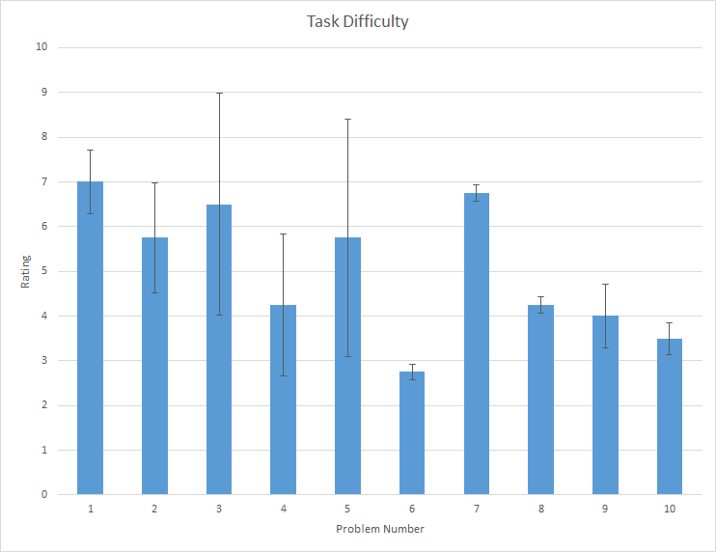
Figure 1. Pilot 1- Task Difficulty Verification.

Further on, a second Pilot test was conducted. During this test, the participants were asked to fill out the provided surveys, which included their input about the appropriateness of the feedback. The appropriateness of the feedback was asked to examine its effectiveness. The results, as shown in Fig. 2, showed differences for the types of feedback. In Fig. 2 it demonstrates that negative politeness was reported as being the highest appropriate overall.

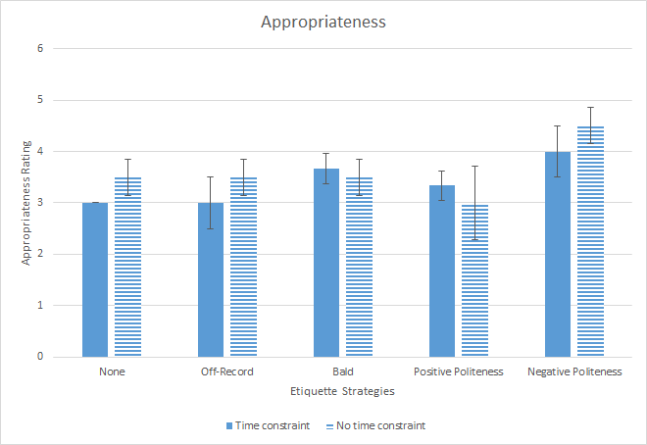
Figure 2. Pilot 2- Appropriatness of Feedback.

During the second pilot test different dependent variables where tested. One of the dependent variables include the temporal demand (time constraint), or the time constraint manipulation verification. In order to verify the participant's temporal demand a subscale of TLX was used to verify whether time constraint manipulation effectively worked during the trials. Some differences, as shown in Fig. 3, were found in the temporal demand for negative politeness and no feedback, but no real differences for the rest of the feedbacks.

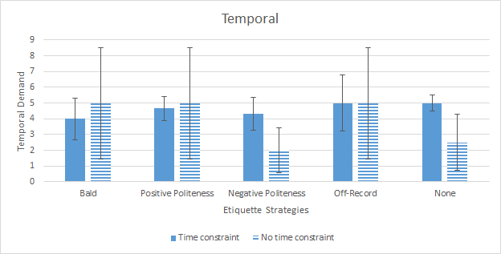
Figure 3. Pilot 2- Temporal Demand (Time Constraint).

Another dependent variable that was considered during the second pilot test was the participant’s task performance. All of the 5 problems during the trial were corrected and scored to gather the participant’s overall task performance. Some participants’ performance trends are shown in Fig. 4, these can be seen in the bald, negative politeness, and no feedback being higher than the others for no time constraint. In contrast, bald, positive politeness, and off-record were found to be higher than the rest for time constrained trials.

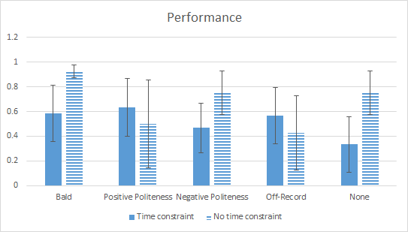
Figure 4. Pilot 2- Paticipants Performance.

DISCUSSION AND CONCLUSION

After conducting the pilot tests, it can be shown that in Fig. 2 negative politeness was reported as having the highest appropriateness of feedback. It was subjectively assumed that participants preferred this etiquette strategy due to its noninvasive nature while they were busy working on the task. After first verifying the difficulty of the tasks, it was important to induce frustration on the participants to gather a baseline of their emotions. The time constraint, however, varied from participants due to the time taken to complete the sample tasks. To further the study, it is important to be constant with the time allowed to complete the physics problem so that each participant has equal amount of time to finish. The manipulation method of time constraint was ineffective to the users as shown by the results of their frustration without a time constraint. When scoring the participants solved problems, the scoring standards were basic enough to score the participants evenly and fairly, however it would be beneficial to find other methods of assessing performance on the tasks.
To further this study on the effectiveness of etiquette strategies, gathering more participants will provide a better understanding on the results on user’s performance and/or mitigation of negative emotions. More than one emotion could have been induced, but due to the total time of the experiment, another induced emotion would take too long to test during the experiment and less people would volunteer. With that, the study could gain statistically significant data to show the distinct differences each etiquette strategy has on a user’s learning experience.
The broad goal of the research is to build a system that will automate the etiquette strategies feedback to the user at the appropriate time to alleviate the negative emotions felt during learning. The capability of the system providing appropriate feedback will enhance the interactions between human and computer.
Since the feedback in the experiment was spoken by the experimenter, the feedback needs to be integrated into the system to measure if the feedback from a system would be effective. Finally the system would need to be able to provide the feedback to other tasks besides physics.

ACKNOWLEDGMENTS

This research was performed at Iowa State University as part of a research internship funded by NSF Grant CNS-1461160.

REFERENCES
Allen, I. E., & Seaman, J. (2010). Learning on demand: Online education in the United States, 2009. Sloan Consortium. PO Box 1238, Newburyport, MA 01950.
Brown, P., & Levinson, S. C. (1987). Politeness: Some universals in language usage (Vol. 4). Cambridge University Press.
Calvo, R., & D'Mello, S. (2012). Frontiers of affect-aware learning technologies. Intelligent Systems, IEEE, 27(6), 86-89.
Fisher, C. D., & Noble, C. S. (2004). A within-person examination [EY1] of correlates of performance and emotions while working. Human Performance, 17(2), 145-168.
Gamalel-Din, S. (2002, June). The Smart Tutor: Student-Centered Case-Based Adaptive Intelligent e-Tutoring. In the Proceedings of the 1st International Conference on Informatics and Systems, Cairo (Vol. 17, p. 20).
Graesser, A. C., Chipman, P., Haynes, B. C., & Olney, A. (2005). AutoTutor: An intelligent tutoring system with mixed-initiative dialogue. Education, IEEE Transactions on, 48(4), 612-618.
Hüttermann, S., & Memmert, D. (2015). The influence of motivational and mood states on visual attention: A quantification of systematic differences and casual changes in subjects' focus of attention. Cognition and Emotion, 29(3), 471-483.
Klein, J., Moon, Y., & Picard, R. W. (2002). This computer responds to user frustration:: Theory, design, and results. Interacting with computers, 14(2), 119-140.
Ni, A. Y. (2013). Comparing the effectiveness of classroom and online learning: Teaching research methods. Journal of Public Affairs Education, 199-215.
Woolf, B., Burleson, W., Arroyo, I., Dragon, T., Cooper, D., & Picard, R. (2009). Affect-aware tutors: recognizing and responding to student affect. International Journal of Learning Technology, 4(3-4), 129-164.
Wu, P., Miller, C. A., Funk, H., & Vikili, V. (2010). Computational models of etiquette and Culture. Human-Computer Etiquette: Cultural Expectations and the Design Implications They Place on Computers and Technology, 63.

