Advancing electrochemical biosensors through nanoscale Pd-Pt deposited textiles

Abstract:
There is a demand for wearable electrochemical biosensors to provide detailed, real-time health analysis for athletes. One possible avenue to fill this demand is through nanostructured textile biosensors that monitor health-related biomarkers (e.g., in the sweat. Sweat contains over 800 potential health-related biomarkers, but said biomarkers are found at low concentrations (i.e., concentration levels that are orders of magnitude lower than those found in blood). This work focuses on improving the sensitivity of textile-based biosensors by depositing both urchin-like platinum (Pt) nanowires and coral-like pladium (Pd) nano/microsturctures directly onto individual textile fibers. The bimetallic blend of both Pt and Pd nanoparticles, known for high catalytic efficiency of hydrogen peroxide (H₂O₂) decomposition, is varied to yield to determine which combination would yield the highest sensitivity. Results demonstrate woven textiles do not provide a reliable enough base for consistent current flow. Future work will be done with nonwoven textiles (i.e., 100% Polyester Fleece).

Introduction:
Today’s athletes use fitness trackers as a non-invasive method to monitor their performance and evaluate their health (e.g. FitBit). However, these commercial wearable devices are limited in the information they can provide to the user. For instance, they do not analyze biomarkers which can be used to indicate conditions such as dehydration or muscle fatigue. Therefore, a wearable biosensor with the ability to analyze electrochemical biomarkers in sweat would allow athletes more effectively monitor their health, determine weather or not they need to refuel, or increase/decrease their work-out routines on the fly when actual exercise is occurring.
Much research has been done in the field of wearable sweat biosensors. For example, Rose et al. have developed a radio-frequency identification (RFID) patch that monitors sweat electrolytes. Some studies have also been performed to construct temporary tattoo sensors to detect other biomarkers such as lactate, sodium, and ammonium (Bandodkar et al., 2014; Jia et al., 2013; Guinovart et al., 2013). However, less attention has been given to research on electrochemical sensors that have been integrated into textiles.
A few textile-based sensors have been created, however, there are acute disadvantages in how they function. Coyle et al. have developed a textile based, replaceable sweat pH sensor, but the sensor’s limitations include the necessary replacement of a sensing strip after each use. Another sensor relies on sweat to be collected in reservoir zones of Evolon, a nonwoven material; hydrophilic channels must be printed on the material for the sweat to be analyzed (Baysal et al., 2014). These biosensors show tremendous promise in sweat-based biosensing, however issues regarding sensitivity and fabrication complexity still need to be addressed.
This work is focused on constructing nanoparticles directly into fabric in a facile manner without the need for complex chemical functionalization or fabric pretreatment methods. Research indicates that the high conductivity of nanometals, especially noble metals, like platinum (Pt) and palladium (Pd), can help yield greater sensor sensitivity in biosensing research because of their material properties (Doria et al., 2012; O’Neill et al., 2004) including the ability to decrease the oxidation-reduction reaction overvoltage for hydrogen peroxide reactions (Lim et al., 2005). In fact, Hasnet et al. (2010) demonstrated that Pt-Pd blends yielded a more efficient catalyst for H₂O₂ decomposition than well-known and highly effective H₂O₂ catalysts such as Pt alone, gold composites, potassium dichromate and magnesium dioxide. This work has developed a bimetallic platinum-palladium nanostructured surface directly onto textile fibers to electrochemically detect H₂O₂, which is a by-product of chemical reactions in oxidase enzymes (e.g., glucose oxidase, lactate oxidase). Future work with these textiles will include the incorporation of glucose oxidase into the fabrication scheme in order to convert the textile into a usable glucose biosensor. The goal of our research is to optimize the textile’s chemical composition and sensitivity, which is one of the necessary components of developing a textile based biosensor.
Methodology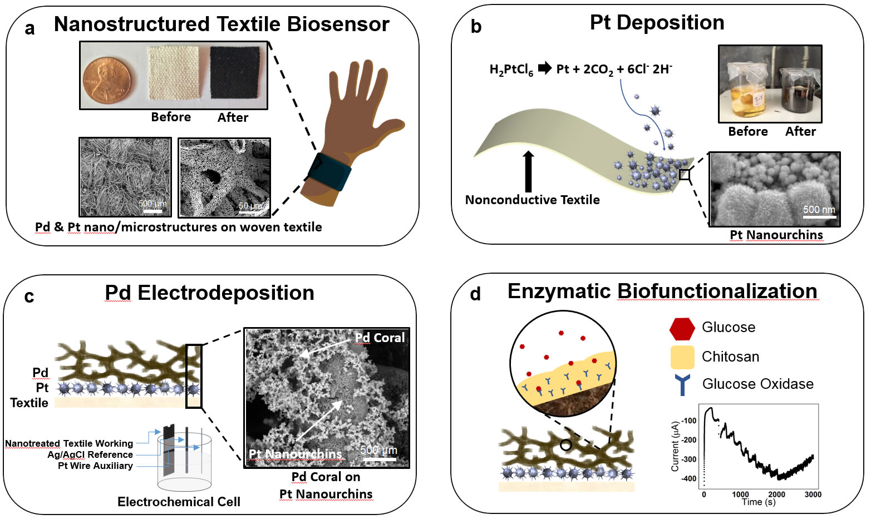
Figure a: The goal of our research is to create a textile sensor that will eventually be incorporated into clothing in order to monitor an individual's health in real time.
Figure b: Pt nanowires were deposited onto a nonconductive textile through a chemical reduction process.
Figure c: Pd coral-like microstructures were then electrodeposited onto the existing platinum textile.
Figure d: Future work – Glucose oxidase, fixed in a chitosan matrix, will then be added onto the existing Pt-Pd textile structure. This will allow for glucose sensing in sweat.
Pre-Test. Using the same electrochemical cell setup, cyclic voltammetry (CV) was performed on each sample to determine the electrode quality of the textile swatch. The electrodes resided in 10 mL of Potassium Ferricyanide buffer solution as the voltage was scanned from -1 V to 1 V in 15 mV steps per second for one cycle. The resulting graphs were compared.
Figure e: SEM Image: Pt-Pd nanostructures on textile
Sensor preparation. Platinum was deposited in the form of urchin-like nanowire as described in previous research (Claussen et al., 2014). This Pt nanowire formation is significantly increase the electroactive surface area of the textile and in previous work has shown to substantially reduce the activation energy needed for H₂O₂ chemical reactions (Claussen et al., 2014). In an experiment by Tominaka & Tetsuya, a certain electrodeposition of palladium was shown to form nanoporous dendrites, which then increases the surface area of the nanometal (2011). In this study, Pd was deposited in six different densities on top of the Pt through galvanostatic cycling in a Pd chloride solution (Claussen et al., 2009). The fabrication process was slightly modified to apply pulses of 2.6 mA/cm² current rather than the original 2.0 mA/cm². Then, the Pd density was determined by the number of pulse cycles that the sample sustained. Three samples were made for each Pd density of 50, 250, 500, 1000, 2500, and 5000 cycles for a total of 18 Pt-Pd textile strips. As seen in the SEM images (see Figure e), the Pd constructed a micro-drendrite or coral structure, much unlike the uniform cubes this method has previously formed. The difference may be the result of Pd particles progressively building off of the uneven Pt nano-urchin base rather than a smooth surface. This development seems to have further increased the sensor surface area. After the nanometal deposition, the textiles were cut into approximately 6 by 15 mm swatches to be evaluated within a three-electrode electrochemical cell for sensing tests.

Sensor sensitivity test. This present study focuses on sensing H₂O₂ because, as a byproduct of glucose enzymatic reactions, one could indirectly produce a glucose sweat sensor (Taguchi et al., 2014).
Amperometry was performed on all samples three times using 10 mL of H2O2 with a 0.5V scan rate and with a three-electrode electrochemical cell with a Ag/AgCl reference electrode, and a Pt disk counter electrode for all procedures. The textile was dunked in 10 mL of PBS buffer as the working electrode and 10 µL of H₂O₂ (0.5 mM concentration increases) was dispensed into the solution at regular intervals. The change in current over the working electrode was recorded for further analysis.
Results and Discussion
Desired results of our experiments include an amperometric i-t curve that shows clear “steps” for each different concentration of H₂O₂. Ideally, the steps of the i-t curve would be of relatively equal size in order to create a linear plot of the concentration vs average current value for each concentration.
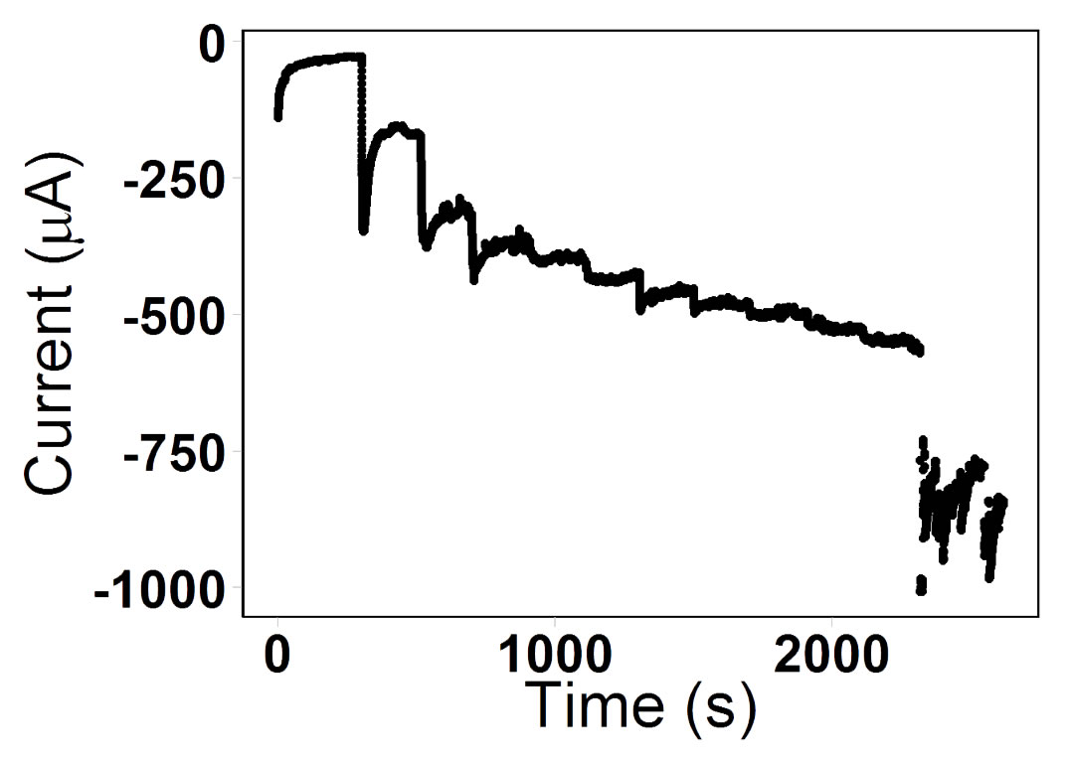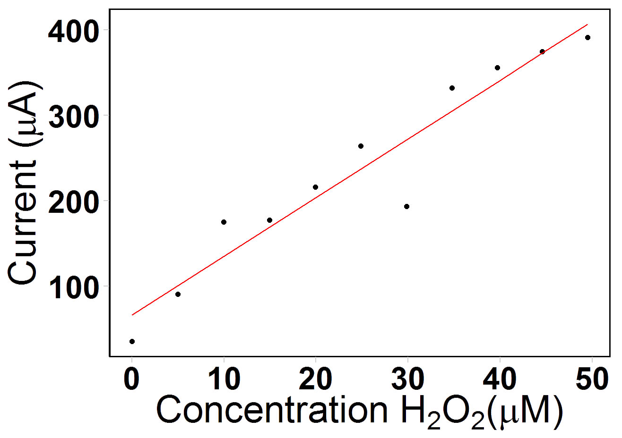
Figure f: An amperometric i-t curve for a Pt-Pd textile (500 cycles of Pd deposition) reacting to changes in H₂O₂ concentration, followed by a graph of the average current value at each concentration level. A linear model was fit to the data and had an R-squared value of 0.92. 48 seconds of noise was removed from the first graph.
Seen in Figure f, some successful results are pictured. The amperometric i-t curve displayed steps of relatively similar size, and this translated into a strongly linear average current per concentration graph (R-squared of .92). Unfortunately, not all of the results have clear, ideal steps. Figure g showed clear steps, however the initial sizes were not consistent, leading to a less linear average current per concentration graph (R-squared of .83). However, in Figure g the average current per concentration graph does show strong linearity starting from the third step. This might imply that the textile is not as responsive at lower concentrations of hydrogen peroxide.
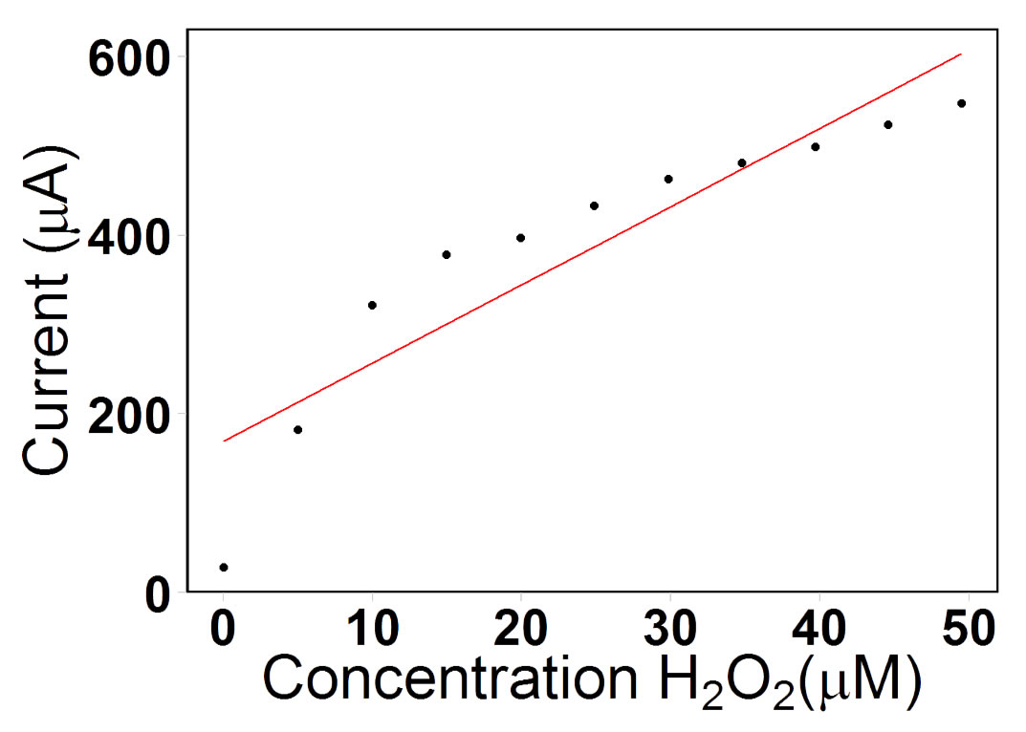
Figure g: An amperometric i-t curve for a Pt-Pd textile (500 cycles of Pd deposition) reacting to changes in H₂O₂ concentration, followed by a graph of the average current value at each concentration level. A linear model was fit to the data and had an R-squared value of .83.
Other results were not as promising. In many instances we had i-t curves that showed no distinct steps, but rather showed a distinctly linear trend. This results in a misleadingly linear average current per concentration plot. Despite that linear trend, this result is not desirable because it does not show the textile properly responding changes in hydrogen peroxide levels.
Some issues that exist in our results are that there are no strong, consistent “steps” in some i-t curves. Some samples showed unclear or irradic steps in their i-t curves. A potential reason for this could be the make of the textile, where the woven threads prevent current flow due to breaks in the contact of nano Pt and Pd. Also, there is not enough data to verify consistent, repeatable reactions to H₂O₂ concentration changes. We have received some quality data, however it is limited in quantity.
Conclusion and Future Work
The data we have collected from our amperometric i-t curves indicate that future development of nanometal-based textile biosensors will have to be approached in a different manner. A handful of the graphs displayed clear steps and a strongly linear response to changes in H₂O₂ concentration, however these results were heavily overshadowed by results that did not meet those criteria. One of the factors that could have contributed to these inconsistent results is the woven nature of our base textile. It may have resulted in too many breaks in contact between the platinum and palladium nanoparticles to allow the surface to be as conductive as was necessary obtain clear results.
Nanometal biosensor research will continue in the future with a nonwoven polyester textile as its base. This polyester textile will either have a thin layer of graphene flakes or carbon nanotubes deposited on its surface to allow for conductivity. Researchers will then deposit platinum and palladium onto the textile’s surface using the same methods described above.
Biofunctionalization is a necessary step in creating any biosensor. Should hydrogen peroxide sensing tests reveal encouraging results for the new nonwoven textile, the textile will need to gain the ability to detect biomarkers. The enzyme glucose oxidase will be incorporated into the textile in a chitosan casing which will allow it the ability to sense glucose. After this, the textile's glucose sensing ability will need to be tested. This will be done through artificial sweat solutions then through human trials.
Finally, the textile will need to be integrated into clothing and an interface will need to be created to allow for functional use.

Works Cited

Bandodkar, A. J.; Molinnus, D.; Mirza, O.; Guinovart, T.; Windmiller, J. R.; Valdés-Ramírez, G.; Andrade, F. J.; Schöning, M. J.; Wang, J. Epidermal Tattoo Potentiometric Sodium Sensors with Wireless Signal Transduction for Continuous Non-Invasive Sweat Monitoring Biosens. Bioelectron. 2014, 54, 603- 609

Baysal, G.; Neşe Kök, F.; Trabzon, L.; Kizil, H.; Gocek, İ.; Kayaoğlu, B. K.; Microfluidic Nonwoven-Based Device as a Potential Biosensor for Sweat Analysis Appl. Mech. Mater. 2014, 490-491, 274-79

Claussen, J. C.; Daniele, M. A.; Geder, J.; Pruessner, M.; Mäkinen, A. J.; Melde, B. J.; Twigg, M.; Verbarg, J. M.; Medintz, I. L. Platinum-paper Micromotors: an Urchin-Like Nanohybrid Catalyst for Green Monopropellant Bubble-Thrusters ACS Appl. Mater. Interfaces 2014 6 17837- 17847

Claussen, J.; Franklin, A. D.; Haque, A. U.; Porterfield D. M.; Fisher T. S. Electrochemical Biosensor of Nanocube-Augmented Carbon Nanotube Networks ACS Nano 3 2009 37- 44

Coyle, S.; Morris, D.; Lau, K.-T.; Diamond, D.; Moyna, N. Textile-Based
Wearable Sensors for Assisting Sports Performance 2009 Sixth International Workshop
on Wearable and Implantable Body Sensor Networks (2009): n. pag. IEEE Explore. Web.

Dastjerdi, R, and M Montazer. "A Review on the Application of Inorganic Nano-Structured Materials in the Modification of Textiles: Focus on Anti-Microbial Properties."Colloids Surf., B 2010, 79, 5-18

Doria, G.; Conde, J.; Veigas, B.; Giestas, L.; Almeida, C.; Assunção, M.; Rosa, J.; Baptista, P. V.Noble Metal Nanoparticles for Biosensing Applications Sensors 2012, 12, 1657- 1687

Guinovart, T.; Bandodkar, A. J.; Windmiller, J. R.; Andrade, F. J.; Wang, J. A Potentiometric Tattoo Sensor for Monitoring Ammonium in Sweat Analyst. 2013, 138, 7031-7038

Jia, W.; Bandodkar, A. J.; Valdés-Ramírez, G.; Windmiller, J. R.; Yang, Z.; Ramírez, J.; Chan, G.; Wang, J. Electrochemical Tattoo Biosensors for Real-Time Noninvasive Lactate Monitoring in Human Perspiration Anal. Chem. 2013, 85, 6553- 6560

Jose, R. M.; Jose, L. E.; Alejandra, C.; Katherine, H.; Juan, B. K.; Jose, T. R.; Miguel, J. Y. The Bactericidal Effect of Silver Nanoparticles Nanotechnol. 2005, 16, 2346-2353

Lim, S. H.; Wei, J.; Lin, J.; Li, Q.; Kuayou, J.A Glucose Biosensor Based on Electrodeposition of Palladium Nanoparticles and Glucose Oxidase onto Nafion-solubilized Carbon Nanotube Electrode Biosens. Bioelectron. 2005, 20, 2341- 2346

O’Neill, R. D.; Chang, S.; Lowry, J. P.; Mcneil, C. J.Comparisons of Platinum, Gold, Palladium and Glassy Carbon as Electrode Materials in the Design of Biosensors for Glutamate Biosens. Bioelectron. 2004, 19, 1521- 1528

Rose, D. P.; Ratterman, M. E.; Griffin, D. K.; Hou, L.; Kelley-Loughnane, N.; Naik, R. R.; Hagen, J. A.; Papautsky, I.; Heikenfeld, J. C.; Adhesive RFID Sensor Patch for Monitoring of Sweat Electrolytes IEEE Trans. on Biomed. Eng. 2015, 62, 1457- 1465

Tominaka, S.; Osaka, T. Nanoporous PdCo Catalyst for Microfuel Cells: Electrodeposition and Dealloying Adv. Phys. Chem. 2011, 2011, 1-13

