Virtual Game Day Visualization

James Oliver¹, Eliot Winer¹, Vijay Kalivarapu¹, Anastacia MacAllister¹
Janae Hoyle², Jesse Smith³, Phillip Thompkins³
Iowa State University Virtual Reality Applications Center, Ames, IA, 50010

1. Iowa State University
2. Tufts University
3. University of Maryland Baltimore County

ABSTRACT

Iowa State University, like many other universities, recruits for its football team through visits to facilities both on and off-season and by using clips of football games and touring facilities. In an effort to break from this stereotype, Iowa State’s Athletics Department has decided to implement a virtual reality application to mimic the experience of being a football player at an Iowa State University home game. The application would also benefit from being taken abroad, so that potential recruits can experience an Iowa State game even from their living rooms. The Game Day Experience application is being compared to the current recruitment videos, using the C6 CAVE and an Oculus Rift head-mounted display. The experiences of the users are being quantified through a Presence Questionnaire, Immersive Tendencies Questionnaire, and an Attention and Experience Questionnaire. It is expected that both implementations of the virtual reality application will be rated more highly than the recruitment videos. More specifically, it is expected that there will be insignificant differences in user experience between the CAVE and head-mounted display versions.
Introduction
Iowa State uses a variety of techniques to showcase their football program to guests, potential donors, and football recruits. If football is in season, they take these guests to games at Jack Trice stadium, the football complex, and other football facilities. However, if these guests can only visit during the off-season or are not able to visit Iowa, they are limited to only visiting an empty Jack Trice stadium, or shown a series of football videos produced by the Athletics department. The off-season recruitment methods do not provide the participant with an immersive experience and are very similar to the way competing football teams showcase their programs. In an attempt to diversify the experience of an Iowa State football game to these off-campus and off-seasons guests, the Iowa State Athletic department has requested the development of a ‘Game Day’ application using Virtual Reality. The simulation will provide participants with the experience of being at an actual Iowa State football game at Jack Trice Stadium. By using the C6, a head-mounted display (HMD), or a desktop computer, users will be able to have a high-quality virtual experience of an Iowa State game no matter where they are in the country. Nevertheless, these virtual platforms are all of a different cost and resolution capability. Therefore, users will be tested to see if the Jack Trice Stadium simulation has significant differences in presence and experience when using a high-cost (such as the C6) or low-cost virtual reality device (such as a HMD). It is hypothesized that while users of the high-cost device may rate the simulation higher than the low-cost device, the low-cost device will still provide users with significant immersion in addition to portability. Also, the simulation is expected, regardless of delivery, to be rated more highly than the pre-existing recruitment videos.

Background
Virtual Reality in Industry and Sports
Virtual Reality (VR) is increasingly gaining the attention of disciplines around the world. It is being developed as a tool by the military to support flight simulations, soldier training, and vehicle navigation (Boas). In the sphere of education, applications like NewtonWorld, MaxwellWorld, and PaulingWorld can be used to learn about motion, electricity, and molecules (Boas). Within the entertainment industry, video game companies are developing software compatible with the Oculus Rift (Ruzanka, 2014). Further applications include documentation, productivity and task optimization, universal remotes, medical interfaces, and commerce (Schweizer). VR is even being developed for therapeutic purposes (Brennan et al, 2013).
While quantities of research have been conducted to examine the user experience in a variety of contexts, from bodies to stress and anxiety to rehabilitation, there have also been investigations into the use of virtual reality as a means to assist athletes across various sports. In 2011, Watson et al used virtual reality to judge the “passability” of affordances, or the ability to take actions, within a rugby environment. After that, Miles et al (2012) examined a variety of virtual environments and concepts like skill transference and the effects of graphical displays on the usability of a system. However, while studies have examined virtual reality as an avenue for training and decision making within sports environments, none have investigated its potential as a means of recruitment for sports.
Defining and Measuring the User Experience
Virtual reality has also been the subject of large quantities of research over the years, a fair amount of which investigates ways to quantify user experiences (Pausch, Proffitt, and Williams, 1997). The primary metric used by researchers is called presence, defined as a user’s subjective psychological response to a virtual reality system, the feeling of “being there” within a virtual environment (Slater, 2003). Related to presence is the concept of immersion, which is used in reference to the objective limitations of the technology used in the virtual reality system (Slater, 2003). Phenomena like the visual cliff (Gibson and Walk, 1960) can be replicated with similar results (Slater, 2004), which opens the door for investigation into other aspects of our interactions with the world, like vision, perception, and body continuity. For example, people can feel more present in a virtual environment if an organic walking method is used, but only if the virtual body can be associated with the participant’s (Slater, Usoh, & Steed, 1995). Furthermore, the façade of ownership of a pair of virtual arms while using a head-mounted display increases presence and allows the illusion of a real arm being touched when one is actually seeing the virtual arm instead (Perez-Marcos, Sanchez-Vives, Slater, 2012). Though not conclusive, research suggests that sense of being within an environment will increase alongside improvements in shadowing and shadow quality (Slater, Usoh, Chrysanthou, 1995). These examples show that if aspects of a virtual environment mimic what we expect from our bodies and from the real world around us, we will be more engaged within a virtual environment, that realism increases presence. This means that by intentionally modeling the Game Day application after past Iowa State football games, the users will report greater levels of presence and involvement within the virtual environment.
Even though there are countless studies on presence within virtual environments, there are still degrees of controversy within the community as to how to measure something like presence. Commonly used is a presence questionnaire from Witmer & Singer (1998). Their measure is sometimes accompanied by their immersive tendencies questionnaire, which gauges people’s openness to that feeling of presence within a virtual world. However, both the Witmer & Singer presence questionnaire and the Slater, Usoh, & Steed presence questionnaire produce similar results overall when used in real and virtual environments (Usoh, Catena, Arman, Slater, 2000). This either shows that such surveys draw parallels between virtual and physical worlds, or that they’re missing the mark. Slater went on to say (2004) that questionnaires may just be calling into being a sense of “presence” or “being there,” because it’s an after-the-fact, subjective construct, and that other approaches are worth looking into. One such approach is a focus on breaks in presence (Slater & Steed, 2000), where the conscious awareness that one is no longer within a simulated environment is worth more than saying someone was “very present within an environment.” Other options mentioned by Slater included physiological data, interviews, and most importantly questionnaires that do not gauge presence, like a metric that measures the subjective user experience alongside an objective measurement of the user’s attentiveness and awareness within a particular virtual environment. Potential football recruits are unlikely to have experienced virtual reality prior to their experiences with the Game Day application, so supplementary testing alongside a presence questionnaire will be used to ensure that the users are not distracted by the novelty of the technology.

Virtual Reality Technologies
While people may put effort into determining how to measure presence and virtual experience, the limits of technology provide implicit limits. For example, the head-mounted-display (HMD) known as the Oculus Rift is a currently popular virtual reality platform. The Rift is viewed as an accessible and rather cost-efficient for consumers, as many video game companies are creating versions of their popular products that are compatible with the device, like Valve’s Team Fortress 2 or Alexander Bruce’s Antichamber (Ruzanka, 2014). It has head-based movement, using technologies like gyroscopes and stereoscopic displays to mimic the mechanics of the human skull (Firth, 2013; Boas). However, the Oculus Rift is subject to phenomena like the screen door effect, where the divisions between pixels on the display are visible, as if one was looking through a mesh surface (Schneider, 2014). Also, visual searches have been found to take longer with head-mounted displays like the Oculus Rift, since the display covers more space than a standard computer screen (Robinson, Czerwinski, Van Dantzich, 1997). Other peripherals include a prototype Near-Eye Light Field Display attempted by NVIDIA (Lanman, Luebke, 2013), the Cast Augmented Reality device (Schweizer), and Cave Automatic Virtual Environments, which are rooms covered with projectors and stereoscopic images to produce an all-around environment (Boas). The portability of a head-mounted display is advantageous for sports recruitment, as using an HMD lets you take the application on the road, and allow recruits to experience it regardless of the technology available in the immediate area.
In his 2007 study, Bowman posed the question of ‘why use the CAVE when a small stereo wall works just as well?’ This research study is partly based on this question, but instead of a stereo wall, the goal is to compare the CAVE to a HMD since such devices are portable and are catching the eye of many companies, from game designers to the Facebook social media platform. A take away from Bowman’s study is that in less complex and easier to understand visualizations in less immersive systems might perform as well as the more immersive ones. This finding seems too generalized with multiple variables that could possibly affect the conclusion. We would like to improve upon this question in order to find a more conclusive result pertaining to the viability of using a less immersive system to achieve a comparable experience to the CAVE.
In order to understand Bowman’s question, we must look into if the technology itself provides for a more immersive, or realistic, environment. Bowman had referenced Brooks’ 1999 study which had anecdotal evidence suggesting that auditory and haptic stimuli might be more important than realistic visuals for some types of phobia therapy. Kwon in 2013 found that sense of anxiety is less correlated to the graphical realism in a VR environment, although the more detailed the environment, the more it provoked a sense of presence. Also, Kwon highlights that anxiety may be induced more by the thought of being in a stressful situation than by the sense of presence. Being able to capture presence through variables not pertaining to the immersive tendencies and visual quality of a system could make lower cost, lower immersion devices a more viable option for certain applications.
Demiralp et al decided to conduct a study in 2006 to quantitatively and qualitatively compare the CAVE to a fishtank display, 3D stereo image monitor with head tracking capabilities. The major conclusion of this study is that participants using a fishtank display performed better than in the CAVE with respect to task performance, comfort and subjective evaluation. But, in this study the users were given a visual search task to find a potato-like structure within different settings, which can be classified as an abstract task. Two years later Forsberg et al improved upon Dermiralp et al’s study. Each study used an identical setup, but Forsberg et al allowed the participants to view the presented data set from many more vantage points than Dermiralp et al’s limited range of spatial tasks. In result of this and different methods for qualitative comparisons, Forsberg et al was able to conclude that the CAVE has better usability, was better in terms of memory and provided a higher sense of presence. The major factors that led to this result is that the CAVE is able to engage the entire body in its simulation since someone is able to walk around within the CAVE walls to perform tasks. Also, the visualizations within the CAVE are scaled to life sized in order to give the user a greater sense of being a part of the simulation. However, while a CAVE may provide larger scale and stronger technology, there are some definite drawbacks. A CAVE requires at least an entire room, and the computers and projectors needed to support however many screens are being used, which means that CAVE technology is not yet at the point where it can be used in more commercial settings or with the public at large. Furthermore, because the user’s visual perception is not completely overridden like with an HMD, someone can simply look down at their feet to see that they are not actually part of the virtual environment, no matter how engaged they may be. Conversely, because users cannot see their bodies while using an HMD, some people may feel that an environment shown through an HMD is unnatural.
Motivations
As covered above, it appears as though virtual reality, while it has been used for a variety of purposes, has not been implemented as a means of recruitment, particularly for a university sports team. Viable implementations of virtual reality include a multi-faced CAVE setup and a head-mounted display. A CAVE boasts more processing power and can provide an experience that surrounds the body. But, using a CAVE requires much in terms of resources, is immobile, cannot replace the user’s perception of their own body, and isn’t readily available to the public at large. Conversely, an HMD can be used with commercially available computers regardless of location, they can override the user’s field of view, and can in some cases even allow realistic mimicking of the user’s body. However, while they’re more widely available than a CAVE, they suffer from situations like the “screen door effect” and are still in development for consumers. To compare the viability of the recruitment application across both virtual reality platforms, one must examine the influence of the user’s experience. The user experience with a virtual environment is commonly measured through metrics like Witmer and Singer’s Presence and Immersive Tendencies questionnaires. While they are subjective, they can be supplemented by measures of attentiveness and awareness with regards to the virtual environment.

Application Development
The Game Day simulation was developed using Unity3D, Autodesk Maya, Adobe Photoshop, and GetReal. Unity 3D was used for animating character models and scripting of both character actions and events within the environment. Maya was used to create and edit character models and apply textures that were edited through Photoshop. Because the crowd avatars were slowing the frame rate, Photoshop was also used to create sprite sheets to simplify the implementation of crowds within a packed stadium. GetReal was used to port the stadium application to a format that could be used by the C6 CAVE.
Across the ten weeks of the project, the team of interns were involved with character designs and textures. A generic model was turned into a member of a marching band through the creation of unique textures and a model for an Iowa State University marching band hat. A purchased model of a football player was turned into 22 specific character models, each with their own jerseys, body types, and ethnicities. Significant polygon reduction and model decimation was done to the football models to keep the frame rate of the application as high as possible across platforms. Also, the interns condensed multiple animations into sprite sheets to create crowds. The interns also played a role in the creation of the experimental design, the selection of experimental measures, and the creation of questionnaires specifically for this study.

Method

A. Participants
The study will have up to 200 participants, recruited from Iowa State University. All participants will be at least 18 years old. People will be excluded from participation in the study if they are visually blind or hearing impaired, as the Jack Trice Stadium simulation (also known as Game Day) requires sight and hearing to be fully experienced. Corrective eyewear is permissible for participants. Potential participants with a history of seizures will not be allowed to participate in the study due to the increased risk of cybersickness while using the C6 or HMD.

B. Materials
The C6 CAVE within the Iowa State University VRAC, an Oculus Rift head-mounted display and a 2D computer display will be used to carry out the simulation. From publications we have pulled the revised versions of the Presence Questionnaire (PQ) and Immersive Tendencies Questionnaire (ITQ) created by Witmer and Singer (Witmer, Jerome, and Singer, 2005). Questionnaires about demographics and attention are used to collect basic information about participants and their awareness of the virtual environment.

Procedures
Participants will be randomly assigned to experience the Jack Trice Stadium simulation using either the C6, a Head-Mounted Display, or a 2D computer screen. The Jack Trice Stadium was developed using the gaming software, Unity3D. Figure 1 shows the Iowa State University football player shown to the participants while shows the Jack Trice stadium shown to the participants. After informed consent has been completed, they will be given the demographic and immersive tendencies questionnaires. Subsequently, participants will be introduced to the virtual reality peripheral that they will be using. Then, the Game Day simulation will begin and the participant will be asked to experience the scenes developed by the researchers. These virtual scenes are built using Unity3D while the control will feature football videos seen by the athletics department. Upon the conclusion of the simulation, participants will be given Witmer & Singer’s Presence Questionnaire and the attention questionnaire. With those completed the study concludes and the participant will be instructed on how to receive compensation.

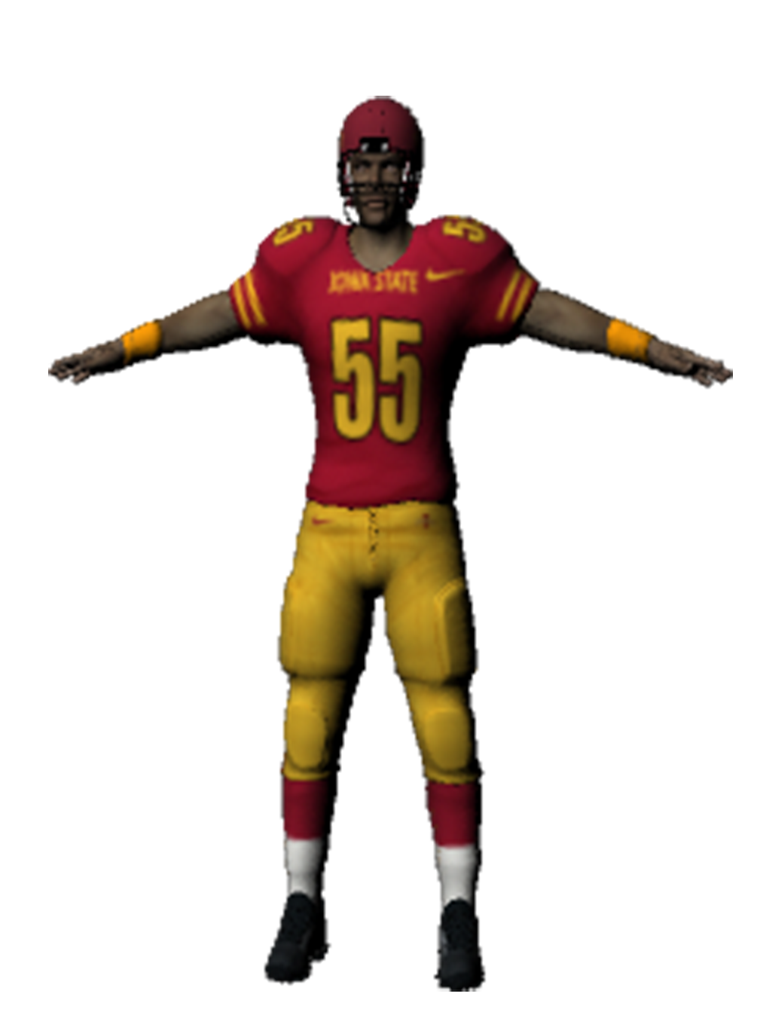
Figure 1: Football Player in Jack Trice Stadium

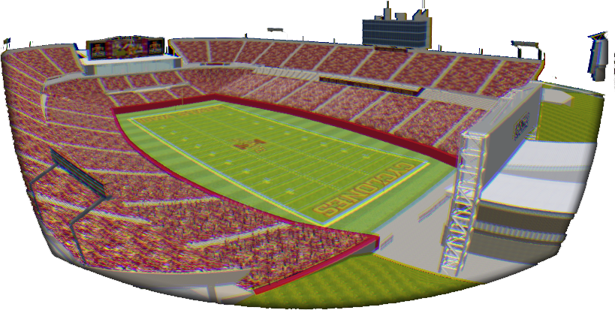
Figure 2: Jack Trice Stadium in Simulation

Results
The team was unable to collect experimental results at this time. User studies shall be conducted in the coming weeks. The group plans to use a t-test to analyze the participant data with regards to individual main effects of testing condition and display technology on user experience. There will be comparisons between the user experience rating for the C6 to that of the Oculus Rift, and both of those to the ratings for the gameplay video. As stated above, it is hypothesized that the simulation will be rated higher by users of the C6 CAVE, but not significantly higher than the users of the Oculus Rift HMD. Also, it is expected that ratings for both the C6 CAVE and the Oculus Rift versions of the application will both be significantly higher than ratings for the gameplay videos.

Discussion
If the hypotheses hold, there will be justification for the Iowa State Athletics department to move forward with the Game Day application for use with future recruitment endeavors. Depending on the success of the application as an actual recruitment tool, the face of college sports recruitment could change drastically in the coming years as technology advances. From an industrial standpoint, if it’s found that the ratings of the HMD are not significantly different from those of the C6 CAVE, then more applications may be developed for commercial use that incorporate the Oculus Rift of a similar head-mounted display.

Future Work and Conclusion
In the future, many new features will be incorporated into the Game Day application to increase its resemblance to an Iowa State Football game. Offensive and defensive plays with the members of both football teams will be created, so that the application can emulate both being within a football stadium and watching a game happen. The marching band members will be revised and given musical instruments to hold while they walk the field, so that they look like more than a group of people walking in formations. A model of the team’s head coach will be created to accompany the athletes through the tunnel run portion, as the coach has traditionally led the Iowa State football team out of the tunnel that leads to the field. When the next iteration of the Oculus Rift is released, it will hopefully remedy the screen door effect and potential for lag, which could be major hurdles for our application, both in terms of presence and the potential for cybersickness.

Acknowledgements
This material supported in part by the National Science Foundation Grant CNS-1156841.

References

- Pausch, R., Proffitt, D., & Williams, G. Quantifying Immersion in Virtual Reality. SIGGRAPH, 1997, 13 - 18.
- Brennan, P. F., Nicolalde, F. D., Ponto, K., Kinneberg, M., Freese, V., & Paz, D. Cultivating Imagination: Development and Pilot Test of a Therapeutic Use of an Immersive Virtual Reality CAVE. AMIA Annual Symposium Proceedings.
- Firth, N. (2013). First wave of virtual reality games will let you live the dream. New Scientist, 218(2922), 19-20.
- Schneider, D., "The 3-D view from above [Resources_Hands On]," Spectrum, IEEE, vol.51, no.2, pp.22, 23, Feb. 2014. doi: 10.1109/MSPEC.2014.6729368
- Lanman, D., Luebke, D., 2013. Near-Eye Light Field Displays. ACM Trans. Graph. 32, 6, Article 220 (November 2013), 10 pgs. http://doi.acm.org/10.11.45/2508363.2508366.
- Boas, Y. A. G. V. Overview of Virtual Reality Technologies.
- Schweizer, H. Smart glasses: technology and applications.
- Witmer, B. G., & Singer, M. J. (1998). Measuring presence in virtual environments: A presence questionnaire. Presence: Teleoperators and virtual environments, 7(3), 225-240.
- Slater, M., Usoh, M., & Steed, A. (1995). Taking steps: the influence of a walking technique on presence in virtual reality. ACM Transactions on Computer-Human Interaction (TOCHI), 2(3), 201-219.
- Slater, M., Usoh, M., & Chrysanthou, Y. (1995). The influence of dynamic shadows on presence in immersive virtual environments. In Virtual Environments’ 95 (pp. 8-21). Springer Vienna.
- Slater, M. (2004). How Colorful Was Your Day? Why Questionnaires Cannot Assess Presence in Virtual Environments. Presence: Teleoperators & Virtual Environments, 13(4), 484-493. Doi:10.1162/1054746041944849
- Slater, M., & Steed, A. (2000). A virtual presence counter. Presence: Teleoperators and virtual environments, 9(5), 413-434.
- Usoh, M., Catena, E., Arman, S., & Slater, M. (2000). Using presence questionnaires in reality. Presence: Teleoperators and Virtual Environments,9(5), 497-503.
- Perez-Marcos, D., Sanchez-Vives, M. V., & Slater, M. (2012). Is my hand connected to my body? The impact of body continuity and arm alignment on the virtual hand illusion. Cognitive Neurodynamics, 6(4), 295-305.
- Schuemie, M. J., Van Der Straaten, P., Krijn, M., & Van Der Mast, C. A. (2001). Research on presence in virtual reality: A survey. CyberPsychology & Behavior, 4(2), 183-201.
- Bangor, A., Kortum, P. T., & Miller, J. T. (2008). An empirical evaluation of the system usability scale. Intl. Journal of Human–Computer Interaction, 24(6), 574-594.
- Bowman, D. A., & McMahan, R. P. (2007). Virtual reality: how much immersion is enough?. Computer, 40(7), 36-43.
- Robertson, G., Czerwinski, M., & Van Dantzich, M. (1997, October). Immersion in desktop virtual reality. In Proceedings of the 10th annual ACM symposium on User interface software and technology (pp. 11-19). ACM.
- The Visual Cliff - Gibson, E.J. and R.D. Walk, (1960). The "visual cliff", Scientific American, 202, 64-71.
- Slater, M. (2003). A note on presence terminology. Presence connect, 3(3), 1-5.
- Brooks Jr, Frederick P. "What's real about virtual reality?." Computer Graphics and Applications, IEEE 19.6 (1999): 16-27.
- Kwon, Joung Huem, John Powell, and Alan Chalmers. "How level of realism influences anxiety in virtual reality environments for a job interview." International Journal of Human-Computer Studies 71.10 (2013): 978-987.
- Demiralp, Cagatay, et al. "Cave and fishtank virtual-reality displays: A qualitative and quantitative comparison." Visualization and Computer Graphics, IEEE Transactions on 12.3 (2006): 323-330.
- Forsberg, Andrew, et al. "A comparative study of desktop, fishtank, and cave systems for the exploration of volume rendered confocal data sets."Visualization and Computer Graphics, IEEE Transactions on 14.3 (2008): 551-563.
- Chuptys, Simon, and Jeroen De Coninck. "Head Mounted Displays."
- Miles, H. C., Pop, S. R., Watt, S. J., Lawrence, G. P., & John, N. W. (2012). A review of virtual environments for training in ball sports. Computers & Graphics, 36(6), 714-726.
- Watson, G., Brault, S., Kulpa, R., Bideau, B., Butterfield, J., & Craig, C. (2011). Judging the ‘passability’ of dynamic gaps in a virtual rugby environment. Human movement science, 30(5), 942-956.
- Jinghui Hou, Yujung Nam, Wei Peng, Kwan Min Lee, Effects of screen size, viewing angle, and players’ immersion tendencies on game experience, Computers in Human Behavior, Volume 28, Issue 2, March 2012, Pages 617-623, ISSN 0747-5632.
- Ruzanka, S. (2014, February). Virtual art revisited. In IS&T/SPIE Electronic Imaging (pp. 901206-901206). International Society for Optics and Photonics.
- Lin, J. W., Duh, H. B. L., Parker, D. E., Abi-Rached, H., & Furness, T. A. (2002). Effects of field of view on presence, enjoyment, memory, and simulator sickness in a virtual environment. In Virtual Reality, 2002. Proceedings. IEEE (pp. 164-171). IEEE.
- Witmer, B.J., Jerome, C.J., & Singer, M.J. (2005). The factor structure of the Presence
Questionnaire. Presence, 14(3) 298-312.

Appendix A: Demographic Questionnaire

DEMOGRAPHIC QUESTIONNAIRE
Please answer the following questions about yourself by circling the response that applies to you.
- What is your age? ________________

- What is your gender? ___ Male ___ Female

- What is the highest level of education you have completed?
___ High School | ___ Undergraduate | ___ Doctorate
___ Trade School | ___ Master’s | ___ Other

- Is your primary language English? ___ Yes ___ No
If “No,” what is your primary language? ___________________

- How often have you used Virtual Reality software?
___ Never | ___ 1-3 times | ___ 4-6 times | ___ 7-9 times | ___ 10+ times

- Are you prone to motion sickness or feelings of nausea? ___ Yes ___ No

- Do you consider yourself a fan of American Football? ___ Yes ___ No

- How many large sporting events have you attended in the past year?
___ None | ___ 1 to 2 | ___ 3 to 4
___ 5 to 6 | ___ 7 to 8 | ___ 9 or more

- If you answered anything but “None” to #8, what sort of events have you attended?
___ Football | ___ Baseball | ___ Soccer
___ Basketball | ___ Softball | ___ Other

  - Were any of these events ISU football games? ___ Yes ___ No

- I am a very passionate ISU Cyclone football fan.
Strongly Disagree | Disagree | Agree | Strongly Agree

- I enjoy the atmosphere of a football game.
Strongly Disagree | Disagree | Agree | Strongly Agree

- I enjoy experiencing football games with my peers.
Strongly Disagree | Disagree | Agree | Strongly Agree

- I would rather have a sideline view of the game instead of being in the stadium seats.
Strongly Disagree | Disagree | Agree | Strongly Agree

- I frequently envision a football game through the player’s eyes during a play.
Strongly Disagree | Disagree | Agree | Strongly Agree

Appendix B: Experience/Attention Questionnaire

EXPERIENCE/ATTENTION QUESTIONNAIRE
Based on your experience in the virtual environment, please respond to the following questions.

1. Did you notice the scoreboard? yes no
If yes, what was the score? _______________

2. Did you notice the cheerleaders? yes no
If yes, what color were their uniforms? __________________

3. Did you notice the marching band? yes no
If yes, what color were their uniforms? ___________________

4. Did you notice the opposing team? yes no
If yes, what color were their uniforms? ___________________

5. Did you notice the mascot? yes no
If yes, what was it? ______________________
If yes, where did you see it? _____________________

6. The immersive environment felt like experiencing a real football game.

Strongly Disagree | Disagree | Agree | Strongly Agree

7. What did you like about the virtual environment?

8. What did you dislike about the virtual environment?

9. Is there anything you would add to the virtual environment?

