Evaluating the Oculus Rift as a VR assembly training tool

Brittney Hill¹, Emma R. Dodoo², Austin Garcia³
Melynda Hoover³, Adam Kohl³, Anastacia MacAllister³, Jonathan Schlueter³, Eliot Winer Ph.D.³

Iowa State University Virtual Reality Applications Center, Ames, IA, 50010

1. Georgia State University
2. The Pennsylvania State University
3. Iowa State University
Abstract
Manufacturing is collectively understood as the making of goods or wares by manual labor or by machinery, especially on a large scale. The addition of machinery to this definition occurred after the Industrial Revolution; introducing new technology that allowed for better and more efficient manufacturing processes. Recent technological advances have introduced potential opportunities with the ability to improve the current production system. Assembly is considered one of the important processes in manufacturing.

Previous studies have shown that product assembly training in the manufacturing industry has predominantly focused on traditional methods such as textbook learning, and more recently, video guidance; though these conventional methods have sufficed for years, when compared to virtual reality, 2D methods of learning have resulted in more errors and an increase in production cost and time. On the contrary, training with the VR counterpart has demonstrated effectiveness and efficiency for the manufacturer by virtue of reduced production time and costs.
This had been displayed through the release of commercial virtual reality (VR) head mounted displays (HMD) and the level of immersion in a virtual environment (VE) is heavily impacted by the amount and type of interaction between the user and the environment.

However, because of the recentness of virtual reality’s commercial availability, research on training interfaces in manufacturing environments is limited. The prototype addressed in this paper was developed to test the viability of using a VR HMD as an assembly training tool with hopes that this tool may be used to improve training processes in the future.

Keywords: Head Mounted Displays, Virtual Reality, Assembly Training, Manufacturing

Introduction
Virtual reality (VR) is a thriving industry with technology that is consistently increasing in popularity. As a result, VR has been applied successfully to hundreds, if not thousands, of scenarios in diverse areas including rapid prototyping, manufacturing, scientific visualization, engineering, and education [1]. With a projected growth of eight billion USD in revenue by 2025, along with its AR counterpart [2], companies and organizations are now more open to adopting virtual reality practices in their workforce than ever before. VR is described as a 4D simulation of the real world, including the 3D geometry space, 1D time and the immersive or semi-immersive interaction interface [3]. The immersive nature of this 4D simulation is what makes VR so attractive to institutions planning to train workers for manufacturing task.

Virtual reality-based training is the world’s most advanced method of teaching manufacturing skills and processes to employees [1]. Instructing newcomers by fully immersing them in a virtual world allows them to acquire an atmosphere of realism that is not otherwise generated in 2D training mechanisms. Studies have concluded that realistic procedural simulations, especially with haptic feedback, lead to better performances, faster performance curves, and a high transfer of operative skill [4].

Though virtual reality has been a presence for nearly half a century, there has been a recent burst of high quality commercially available VR head mounted display’s (HMD’s) that are affordable for the average consumer. This has expanded possibilities for applicable fields where VR could have an impact, such as assembly training. Consequently, research in factory training lacks extensive reviews of plausible user interfaces. This paper's aim is to analyze research conducted on training interfaces and virtual reality simulations in order to conclude a comprehensive user interface for assembly training. This paper test the feasibility of employing virtual reality immersive environments as a method to train workers for assembly line task.

By simulating authentic workshop elements to create a realistic visual environment, it is inferred that a trainee will gain better knowledge of their production environment and task prior to the time allotted for actual production.

Background
The benefits that transpire when adopting virtual reality for training purposes have been documented in academia for years and all with relatively similar results. Laparoscopic surgery is presumably the most researched when it comes to virtual reality training simulations, and the research yields astounding results.

VR-trained surgeons reported 29% less time spent performing operations and were 5 times less likely to cause errors [5]. Regardless of the skillfulness and complexity of the surgeries, participants were still adept at performing the task with virtual reality training. This demonstrates the potential scalability of training applications, and the possibility to train for complex manufacturing using VR. Another frequently researched topic is the use of virtual reality training for flight simulators. In flight simulations, VR training not only benefits cost-reduction and time consumption but it also can contribute to testing new aircraft concepts [6]. However, most papers in academia glide over the many user interface elements of their training simulators, leaving UI research in this field lacking in depth. Though there is research that covers virtual reality UI’s generally, most are primarily focused on VR in gaming applications. This is likely because virtual reality is more commercially known for gaming.

Now, with the expansion of the virtual reality industry, and a higher demand for VR training simulations, it is plausible to continue UI research in fields other than gaming. For this reason, the main focus of this paper is to explore the usability of a training interface for mock airplane wing assembly in order to better understand how different elements of the interface affect the user's retention of information.

Methodology
The methods section will discuss the process for hardware selection, UI development and implementation and the prototype development process. The hardware section will talk about why the Oculus Rift was chosen along with key features that support why it should be used with manufacturing training. The UI development section will explain the decisions made due to existing research. The last section, application development section will explain the tools which were used to develop the application.

Hardware Platform Used for Development
A head-mounted display (HMD) is a method used to transfer images to the brain through an LCD panel. The usage of VR HMDs has become more common and popular from its first appeared around the 1930s. Although VR has been thought to be used primarily for bettering video games and social networking in a virtual environment, VR is seen being used more in institutions and industries such as the medical, education, military and manufacturing.

The Oculus Touch controllers have been designed for the human hands to experience a natural feeling when holding the controllers. Because of the natural feel of the user’s fingers falling into place when gripping the Touch controller, it allows the user to understand movements in a short amount of time [7], [8].

The ergonomic Oculus Touch controllers provide tactile force feedback, an advantage the Oculus has over the HTC Vive [9]. This aided us in making a decision to use the Oculus Rift. The feedback reproduces shape, roughness, and rigidity which acts as a substitute of the visual presentations of information [10].

The Oculus Rift requires, at least, an Intel Core i3-6100 and NVIDIA GeForce GTX or AMD Radeon RX 470 and AMD FX4350, 8GB RAM, Windows 7, a compatible HDMI 1.3 video output and two USB 3.0 ports. This power allows 1080x1200 resolution per eye at a 90Hz refresh rate and a 110-degree field of view through a Pentile OLED display which generates the 3D content. Other features include spatial sound, built-in mic, accelerometer, gyroscope, magnetometer, and a constellation tracking camera. The Oculus Rift is seen in Figure 1.

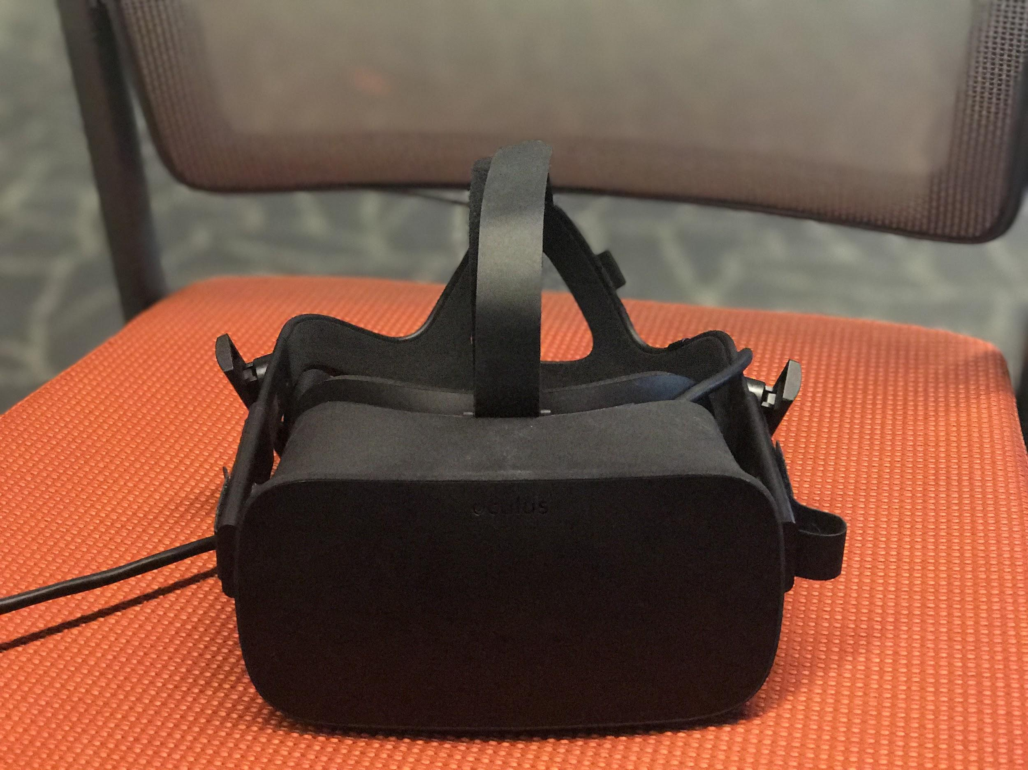
Figure 1. The Oculus Rift.

UI Development
When deciding how to implement a factory environment in the Oculus, a setup similar to a previous study comparing model based instructions (MBI) within Desktop MBI, Tablet MBI and Tablet AR was chosen [11]. The setup was designed to be a replica of a manufacturing work cell.
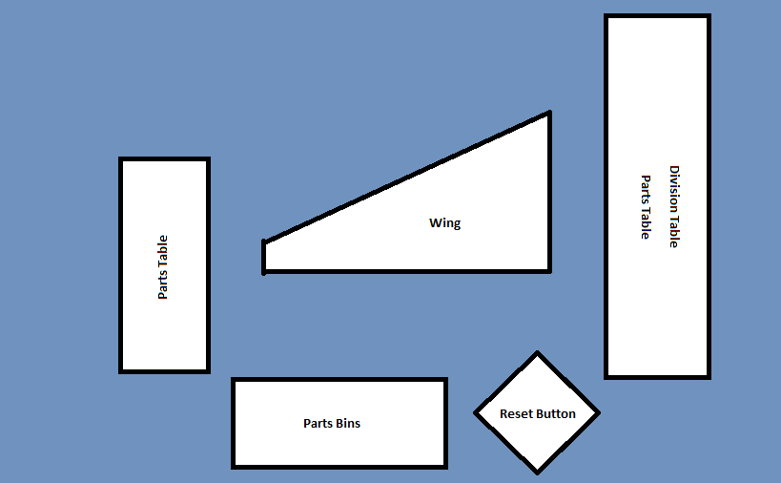
Figure 2. Aerial view of manufacturing cell.

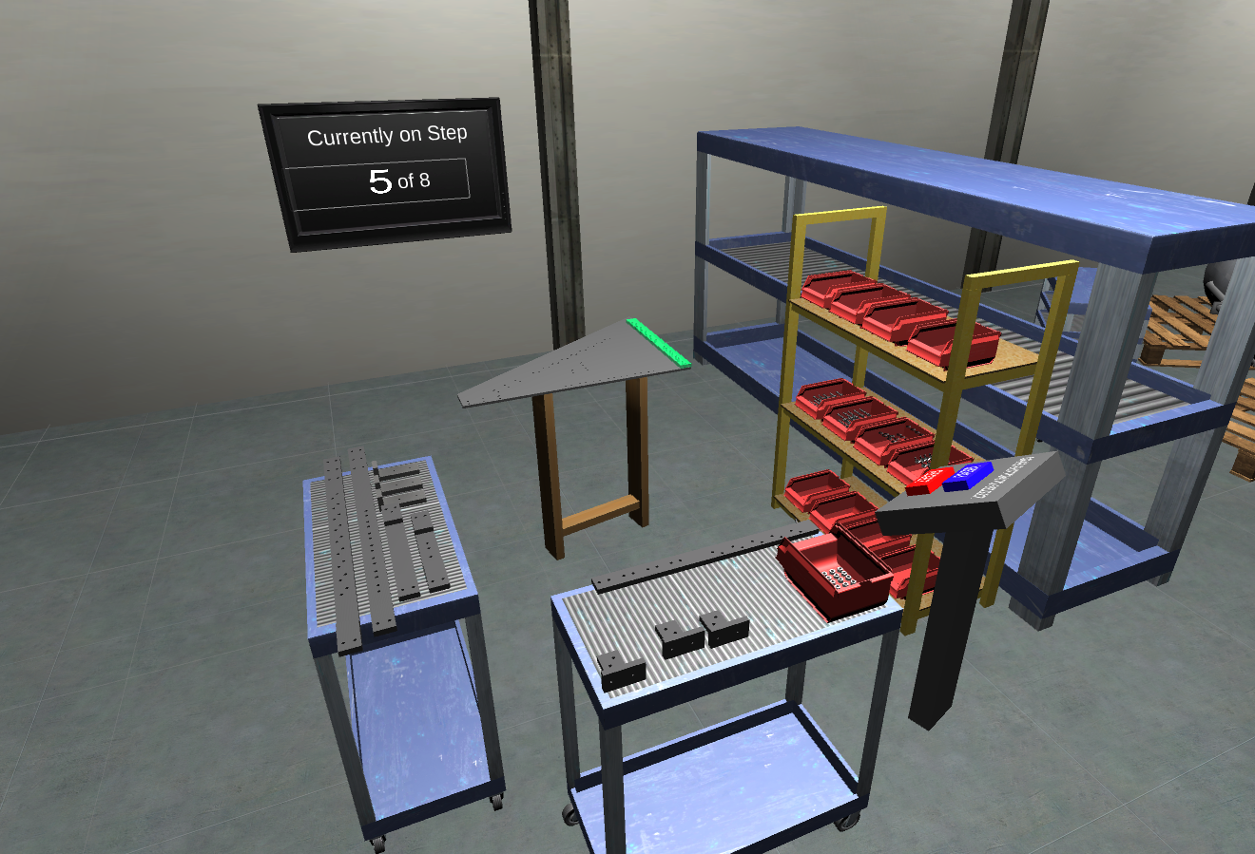
Figure 3. VR training area.

The menu environment allows the user to interact with floating buttons via a pointer using the index trigger on an Oculus Touch controller. From this area, the user can choose to enter a tutorial, the general wing assembly, or exit the application. When the wing assembly is selected, the manufacturing environment loads with the completed assembly shown. A control panel is located directly to the right of the assembly, allowing the user to begin the assembly or go back to the menu. Everything within this scene uses the hand trigger on the Oculus Touch, which requires the middle finger. Thus, the grabbing motion is consistent between the assembly parts and the buttons. Once the start button is grabbed, the control panel relocates to a corner and presents options to reset the assembly or return to the menu. The first animation becomes visible and indicates where to place the first piece. The piece to be placed is highlighted until picked up, and will re-highlight if it is let go of for a certain amount of time. If the piece is located in a bin with multiple of the same part, the bin is highlighted and a large number is displayed above. Behind the assembly a television screen displays the current step number along with the total number of steps. When the piece is held or dropped into a position that is within a certain tolerance, it will snap into place. This begins the next set of animations and updates the step number.

UI Implementation
In this section, the researchers will explore the different types UI elements the prototype uses. Reasons for animation feedback, choice of color, selection, snapping, and element placement will be included as these affect how a user interacts and learns within a virtual environment.

Animation Feedback
Animations can improve the speed in which individuals learn tasks that involve natural and physical movements, compared to static pictures [12]. Animations are used to grasp the attention of the user through visual cues; they inform a user to perform an action, and when the action has been completed as they are an intuitive representation of assembly instructions [13], [14]. This application focuses on the addition of object selection highlighting, pulsating, and color change (when the user selects and puts down an object), as seen in Figure 4. When the object is set down, there is a wait period before the highlight animation restarts. This allows the animation to not be an annoyance and lets the user inspect the part. Through animated feedback, it is anticipated that the user will realize an action has been performed and will learn to remember specific these actions. It is through animation that the user’s cognitive and short-term memory load is reduced [15].

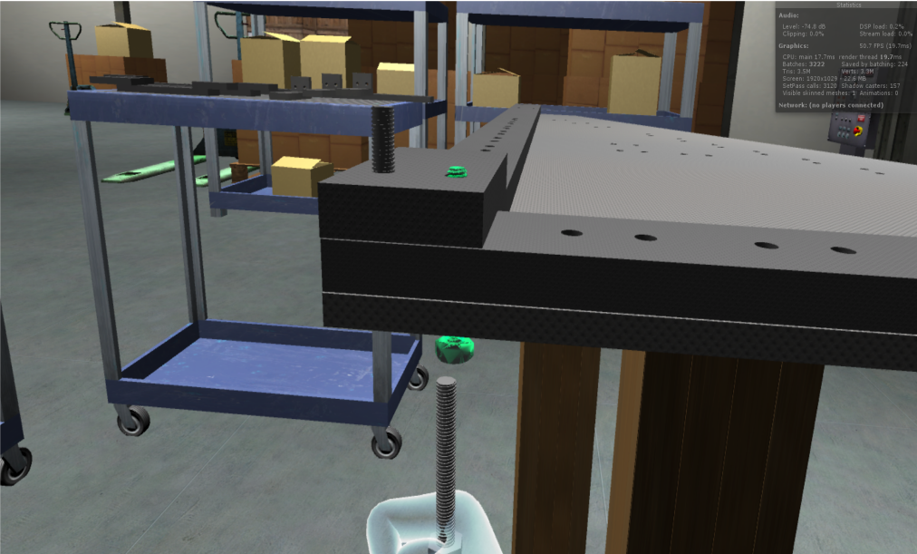
Figure 4. Animation showing user where to place object.

Color Choice
Color combinations are a focus of the project in the implementation. The right selections can improve memory performance and retention [16]. The specific colors that have been chosen are to ensure that users remembers the actions taken throughout their virtual experience in the manufacturing assembly environment. Pure black-and-white conditions have been proven to be disadvantageous in virtual environments, thus, they were not used [16], [17]. For the user to feel comfortable in the environment while training, a warm color of yellow is used [16]. RGB yellow (255, 248, 0, 122) was used for object selection. It paved as a method to make users pay attention to which objects they should be selecting. Cool colors were used to hint users as to what their next actions would be. RGB green (0, 173, 80, 139) was used for hinting at users, where to place each selected object. Animations were given a transparent effect as well. This helped inform the user that the animation was instruction, not an interactive part. It is predicted that the provision of different colors to specific actions will allow the user to familiarize themselves with each action, thus helping when the user is sent onto the actual manufacturing floor.

Element/Tool Placement
In creating the environment, a manufacturing cell was replicated. All objects including bins of nuts, screws and washers and wooden parts were positioned at distances comfortable to the user. The project uses distances of 0.5 meters or more to gain the required comfort for the user and to reduce eye-strain [17]–[19]. The researchers anticipate that with the close proximities of tools from the center manufacturing table, users will familiarize themselves, through training, with the objects and tools needed for product assembly.

Snapping
Snapping alignments allow the user to position virtual objects onto dynamic, real world scenes [20] It is anticipated that because the user’s placed objects within the environment are carefully tweaked into the correction position, they will learn the alignments of each object per action taken.

Selection: Pointing
Viewpoint motion and control within virtual environments have been proven beneficial to virtual environments [21], [22]. Pointing is implemented when the user selects options on the menu. This increases speed and accuracy, making pointing a good choice. [22]. The researchers anticipate that after the user passes the ‘wow’ factor, which occurs the first time they experience pointing in a VE, the concept of pointing to select objects will be learned extremely fast the [23].

Selection: Grabbing
The ability to grab objects within a virtual environment (VE) is essential as it is important to make the virtual world feel as real as possible.
With the aid of the Oculus Touch, the manufacturing assembly prototype uses a grab function which will allow the user to reach out and select tools needed for the required product assembly. The action of reaching out to grab objects in a VE occurs because it is a natural behavior easily learned in the real world in which virtuality exploits [23]. Grabbing is used to interact with the control panel within the assemblies in order to keep interaction consistent within each scene. The use of only a single button allows easier for easier use by those unfamiliar with traditional gamepads or controls.

Prototype Development
In this section, the researchers will explain the concept of the application, which tools were used and challenges that had to be overcome.

A VR manufacturing assembly floor prototype was developed using Unity, the Oculus Rift, and the Oculus Touch. VR presents the opportunity of reducing hazards that have the risk of personal injuries or damages to expensive equipment. This allows the user to explore the interactive VE, and gain the knowledge and understanding of the task without physically being put into a costly or harmful environment.

The prototype allows the user to practice each step of the airplane wing assembly, by directing the user on which assembly parts to pick and where to place them. For the purpose of training the user and making the prototype more interactive, a UI is placed around the assembly and parts. The UI has animations that clue the user in on what assembly part to pick up via pulsating, numbering, and highlighting. For every step that requires the grabbing of an assembly part, a yellow pulsating highlight is placed to tell the user the object needs to be picked up. For every placement step, a green highlighted animation is placed to tell the user how and where the selected object should be placed. The program continues to tell the user to grab and place objects until the airplane wing assembly has been completed.
Unity was used to create the VE as it allows for both swift integration with the Oculus Rift and an established asset store that supports the ease of development [17].

An issue with framerate became apparent when importing highly detailed 3D models from SolidWorks®. When a bin full of highly detailed screws was looked at, the number of vertices in frame passed thirty million. This slowed down the application considerably; a frame rate below thirty is disruptive to the immersivity level of VR. Using SAP Visual Enterprise Author 9.0, models with an excessive number of vertices were decimated to different levels depending on the model. This was mostly applied to smaller models with a high level of detail. This is because a small decimated object is barely noticeable and does not detract from the users understanding of what the object is. Overall this increased the frame rate though other factors still had an impact.

A proximity snapping technique was used for part placement as it gives a natural feel of assembling to the user [24]. Snapping also informed the user that the step has been completed and they can move on. Each piece required an individual tolerance set based on trial and error due to varying part shapes and sizing. Small symmetrical parts presented a challenge as the tolerances caused frustration when attempting to place them in the correct position. Because of this, a separate method of snapping had to be developed. Thus it was challenging to keep consistency between large object snaps and small object snaps.

Discussion
Developing with Unity for an Oculus Rift proved to be a viable combination for the creation of a manufacturing environment. The Oculus Rift's commercial influence is strongest in the gaming industry. So, when paired with the Unity gaming engine, the combination allowed for easy environment creation. However, the presumed areas of improvement stem from the Oculus Rift more than the Unity gaming engine. The reason for this presumption is because the tethered element of the Oculus Rift does not allow users to explore the 3D environment to its full potential. This hindrance makes larger movements, like walking across the room, only possible with a form of teleporting or fully dis-concordant joystick movement. The limited walking capabilities do eliminate some aspects of realness from the simulation. Though the tethered nature of the Oculus Rift restricted the authors to a smaller simulated workspace, the next iteration of VR HMDs is likely to include wireless integration; As a result, the authors infer that this tethering problem will not be an issue for long.

The use of 3D models with a high vertex count will present a challenge to anyone attempting to put unaltered models straight into Unity. Thus, model decimation will prove vital in the development of VR training applications where models need to only pass a visual inspection.

Conclusion
When testing how feasible using the Oculus Rift technology for a wing assembly training simulation would be, the authors concurred that the application proved to have the potential to improve the current 2D methods of training significantly. Previous research in manufacturing training and UI elements was incorporated into the researcher’s prototype with the intention to create a more informative and realistic training process. The tethered aspect of the Oculus did hinder this application's full potential, however further advances in the VR industry promise untethered devices in the near future. Overall, the benefits that virtual reality training will bring to the manufacturing industry are profound. Further research in this field will allow for companies to gain a better understanding of how virtual reality can benefit their work performance and decrease their training expenditure. As virtual reality technologies continue to expand, the authors believe that virtual reality training simulators will become more prominent in factory training.

Future Work
In the future, the authors would like to run a study on the cognitive work user’s exhibit while using the application. Though this method of training may appear easier to learn, easier learning is not the end goal of this application. Studies have shown that germane learning does have a positive impact on knowledge retention. So, the authors would like to test whether this application cognitively stimulates the trainee enough for maximum information retention.

It would also be beneficial to test this training simulation in actuality. By allowing users to go through the training simulation, then allowing them to try to build the model with the knowledge they learned, the authors can test if this interface for training has a positive correlation with worker errors and time spent on the task.

Acknowledgements
This research was performed at Iowa State University as part of a research internship funded by NSF Grant CNS-1461160.

References
[1] T. Mujber, T. Szecsi, and M. Hashmi, “Virtual reality applications in manufacturing process simulation,” J. Mater. Process. Technol., vol. 155156, pp. 1834–1838, 2004.
[2] H. Bellini, W. Chen, M. Sugiyama, M. Shin, S. Alam, and D. Takayama, “Virtual & Augmented Reality: Understanding the race for the next computing platform,” 2016.
[3] A. Y. C. Nee, S. K. Ong, G. Chryssolouris, and D. Mourtzis, “Augmented reality applications in design and manufacturing,” CIRP Ann. - Manuf. Technol., vol. 61, no. 2, pp. 657–679, 2012.
[4] O. A. J. Van Der Meijden and M. P. Schijven, “The value of haptic feedback in conventional and robot-assisted minimal invasive surgery and virtual reality training: A current review,” Surgical Endoscopy and Other Interventional Techniques, vol. 23, no. 6. Springer, pp. 1180–1190, Jun-2009.
[5] N. E. Seymour et al., “Virtual reality training improves operating room performance: results of a randomized, double-blinded study.,” Ann. Surg., vol. 236, no. 4, pp. 458-63–4, 2002.
[6] T. Aslandere, D. Dreyer, F. Pankratz, and R. Schubotz, “A Generic Virtual Reality Flight Simulator.”
[7] “The difference between Oculus Touch, HTC Vive, PlayStation VR and Windows Mixed Reality controllers | VRHeads.” [Online]. Available: https://www.vrheads.com/difference-between-oculus-touch-htc-vive-and-playstation-vr-controllers. [Accessed: 31-Jul-2017].
[8] “Oculus Touch vs. HTC Vive - Which Is The Better VR Controller?,” 2016. [Online]. Available: https://uploadvr.com/oculus-touch-vs-htc-vive-better-controller/. [Accessed: 03-Aug-2017].
[9] D. W. F. van Krevelen and R. Poelman, “A Survey of Augmented Reality Technologies, Applications and Limitations,” Int. J. Virtual Real., vol. 9, no. 2, pp. 1–20, 2010.
[10] V. Chouvardas, an Miliou, and M. Hatalis, “Tactile display applications: A state of the art survey,” 2nd Balk. Conf. Informatics, pp. 290–303, 2005.
[11] T. Richardson, S. B. Gilbert, J. Holub, F. Thompson, and A. MacAllister, “Fusing Self-Reported and Sensor Data from Mixed- Reality Training Recommended Citation.”
[12] M. Wong, J. C. Castro-Alonso, P. Ayres, and F. Paas, “Gender effects when learning manipulative tasks from instructional animations and static presentations,” Educ. Technol. Soc., vol. 18, no. 4, pp. 37–52, 2015.
[13] N. N. J. Mitra, Y.-L. Y. Yang, D.-M. D. Yan, W. Li, and M. Agrawala, “Illustrating How Mechanical Assemblies Work,” Commun. ACM, vol. 56, no. 1, pp. 106–114, 2013.
[14] M. L. Yuan, S. K. Ong, and A. Y. C. Nee, “Assembly Guidance in Augmented Reality Environments Using a Virtual Interactive Tool,” Int. J. Prod. Res., vol. 46, no. 7, pp. 1745–1767, 2005.
[15] B. Shneiderman, “Visual Analytics: New Tools for Gaining Insight from Your Data,” 2000.
[16] M. A. Dzulkifli and M. F. Mustafar, “The influence of colour on memory performance: a review.,” Malays. J. Med. Sci., vol. 20, no. 2, pp. 3–9, Mar. 2013.
[17] G. Evans, J. Miller, M. Iglesias Pena, A. MacAllister, and E. Winer, “Evaluating the Microsoft HoloLens through an augmented reality assembly application,” vol. 10197, p. 101970V, 2017.
[18] M. Alger, “Visual Design Methods for Virtual Reality,” no. September, p. 98, 2015.
[19] T. Shibata, J. Kim, D. M. Hoffman, and M. S. Banks, “Visual discomfort with stereo displays: Effects of viewing distance and direction of vergence-accommodation conflict.,” Proc. SPIE, vol. 7863, p. 78630P1--78630P9, 2011.
[20] B. Nuernberger, E. Ofek, H. Benko, and A. D. Wilson, “SnapToReality: Aligning Augmented Reality to the Real World,” Proc. 2016 CHI Conf. Hum. Factors Comput. Syst. - CHI ’16, pp. 1233–1244, 2016.
[21] C. Ware and S. Osborn, “Exploration and Virtual Camera Contro l in Virtual Three Dimensional Environment s,” pp. 175–183, 1990.
[22] D. A. Bowman, D. Koller, and L. F. Hodges, “Travel in Immersive Virtual Environments : An Evaluation of Viewpoint Motion Control Techniques Georgia Institute of Technology,” Proc. 1997 Virtual Real. Annu. Int. Symp., p. 45-, 1997.
[23] K. M. Fairchild, B. H. Lee, J. Loo, H. Ng, and L. Serra, “The heaven and earth virtual reality: Designing applications for novice users,” Proc. IEEE Virtual Real. Annu. Int. Symp., no. July 2015, pp. 47–53, 1993.
[24] J. M. Ritchie, R. G. Dewar, and J. E. L. Simmons, “The generation and practical use of plans for manual assembly using immersive virtual reality.”

